



Evaluating the Effectiveness of supplementing Army Recruit Driver Training with Hazard Awareness e-training

Lisa Dorn and David Nickerson
Human Factors Department

School of Engineering

September 2011

© Cranfield University 2011. All rights reserved. No part of this report may be reproduced without the written permission of the copyright owner.

CONTENTS
Page
EXECUTIVE SUMMARY
1 INTRODUCTION
1 The Effect on Driver Risk of Age
2 Figure 1.1: Relative Cause of Death by Age Range in OECD Countries
3 Figure 1.2: Driver Fatalities per Million Population for Different Age Groups, Over Time
3 Figure 1.3: Proportion of Young People in the Population and in Driver Fatalities
4 Table 1.1 Fatality Rates for Licensed Car Drivers Aged 17-20
5 Figure 1.4: KSI Casualties per Million Population Rates by Road User Type and Age: 2009
6 Table 1.2 Distribution of Fatalities and Serious Injuries Resulting from Young Driver Crashes
6 Figure 1.5: Reported Fatalities in Accidents Involving Young Car Drivers (Aged 17 to 24) in the UK, 1994-2009

7 2. Gender and Driver Risk

8 Figure 1.6: Driver Fatalities by Gender and Age, per Million Population
9 Figure 1.7: Driver Crash Involvement by Age and Gender, Western Australia 1989-1992
9 Figure 1.8: Involvement in Fatal Crashes of Young Male and Female Drivers per Million Kilometres Driven
10 Figure 1.9: Passenger Fatalities By Age and Gender

10 3. Being in the Army; Effect on Driver Risk

11 Figure 1.10: Comparison of Land Transport Accident Fatality Rates for Army, Navy and RAF 2001-2010
13 Figure 1.11: Standardised Mortality Ratios for Land Transport and Other Accidents in the British Army, 2001-2010

14 4. Army Category B (Car) Driver Training

14 5. Risk Factors and Countermeasures

14 5.1 Experience
16 Figure 1.12: Age and Driving Experience—Crashes per Million Kilometres Driven for Drivers Who Attain Licences at Age 18, 21, 23-27 and 30-40
17 Figure 1.13: Crash Rates By Licence Status and Months of Licensure
18 Figure 1.14: Monthly Accident Rate Comparison: Newly Licenced Drivers Who Started Learning to Drive at 16 Years-old v. Those Who Started Learning at 17.5 Years-old (Licensing Age in Sweden: 18 Years-old)
19 Table 1.3 Comparison of Injury Accidents Per 1,000 Licence Holders Per Month Between Newly Licenced Drivers Who Started Learning to Drive at 16 Years-old and Those Who Started Learning to Drive at 17½ Years-old
20 5.2 Typical Young Driver Crashes
21 Figure 1.15 Pattern of Percentages of Speed-Related Fatal Cases By Driver Age
21 Figure 1.16: Percentage of Bend Accidents By Driver Age for At-Fault Drivers
22 Figure 1.17: Percentage of Fatalities Not Wearing Seat-belts by Driver Age

23 5.3 Brain Development
24 5.4 Situational Awareness and Hazard Perception

25 6. DRIVE iQ e-learning

26 Figure 1.18: The Goals for Driver Education (GDE) Matrix

28 METHOD

28 7.1 Objectives
7.2 Participants

30 7.3 Design & Procedure
31 Figure 7.1: The Experimental Design of the Study
32 7.4 Questionnaires
7.5 Statistical Analysis of Questionnaire Responses
33 7.6 Driving Test Data
33 7.7 Specification of DRIVE iQ for the Trial

36 RESULTS

36 8.1 DRIVE iQ Responses
37 OBJECTIVE 1: DRIVE iQ Acceptability
38 Figure 8.1: DRIVE iQ Enjoyment after Stage 1 Training
Figure 8.2: DRIVE iQ Enjoyment after Stage 2 Training
39 Figure 8.3: DRIVE iQ identifies weaknesses after Stage 1 Training
40 Figure 8.4: DRIVE iQ identifies weaknesses after Stage 2 Training
41 Figure 8.5: DRIVE iQ improves driving performance after Stage 1 Training
42 Figure 8 6: DRIVE iQ improves driving performance after Stage 2 Training
43 Figure 8.7: DRIVE iQ improves knowledge of hazards after Stage 1 Training
44 Figure 8.8: DRIVE iQ improves knowledge of hazards after Stage 2 Training
45 Figure 8.9: DRIVE iQ improves knowledge of driving risks after Stage 1 Training
46 Figure 8.10: DRIVE iQ improves knowledge of driving risks after Stage 2 Training
47 Figure 8.11: DRIVE iQ not necessary for learning to drive after Stage 1 Training
48 Figure 8.12: DRIVE iQ not necessary for learning to drive after Stage 2 Training
49 Figure 8.13: DRIVE iQ easy to use after Stage 1 Training
50 Figure 8.14: DRIVE iQ easy to use after Stage 2 Training
51 Figure 8.15: DRIVE iQ helps in safer driving after Stage 1 Training
52 Figure 8.16: DRIVE iQ helps me in safer driving after Stage 2 Training

53 OBJECTIVE 2: Questionnaire Responses
58 8. Driving Test Results

60 Table 8.1 SPSS Frequencies Output for Driving Test Results

62 DISCUSSION OF RESULTS

63 RECOMMENDATIONS

64 References

69 Appendix A Demographics of Participants
73 Appendix B Questionnaire
76 Appendix C Driving Test Results

Executive Summary

Young drivers are overrepresented in road casualty statistics, with males being at higher risk than females. There is a subgroup at even higher risk: young (predominantly male) soldiers serving in the Armed Forces, who are more than twice as likely to be killed in road crashes than UK citizens of the same age and gender, with around 80% of casualties occurring while soldiers are off duty. The annual National Statistic Notice on deaths among UK regular Service personnel has consistently identified that road traffic collisions are the single largest cause of death since at least the early 1990s Apart from the tragic human costs, there are also escalating costs of damage to military vehicles that may be reduced with better training.

The Army wants its personnel to be safe but it also needs soldiers who can drive. Most new recruits join the Army without a driving licence and receive driving tuition to obtain a Category B (car) driving licence as part of their initial military training. All Army training has to be cost-effective: driver training that does not result in students’ passing the driving test is regarded as “wastage.” To make the maximum use of military resources, the MoD’s Category B driving licence acquisition training for a young recruit takes between two to three weeks to complete. Massed driving practice means that driving skills can be acquired rapidly. However, critical driving skills such as hazard perception may not be well embedded post-test.

Category B driver training focuses on the mechanical skills of driving and fails to consider knowledge and skills at the higher levels including self-reflection of personal tendencies and effects of passengers in the car, the dangers of driver impairment and the circumstances under which a novice driver is likely to be involved in a crash. Also, the ability to anticipate hazards is a critical competency for safe driving but given the pressure on military resources there is little opportunity to train hazard perception skills.

One way of supplementing the MoD’s driver training to include the required level of knowledge and skills without over-burdening resources is to deliver e-training. Providing a better driver education on risk factors and hazard perception skills via e-training is low cost but highly effective. Research showing the benefit of using this approach demonstrates a reduction in reoffending rates amongst young drivers (af Wåhlberg, 2010) and improved hazard perception skills for novice drivers to the level of an experienced driver (Isler, et al, 2008) using e-training designed by a driver education software company called a2om. One of the main functions of a2om’s DRIVE iQ is to help users to develop situational awareness and hazard perception. It does this with video sequences shot in high definition video that have three rearward mirror views synchronized with the forward action. Part of a car’s interior is also visible in the foreground so that normal instruments (particularly the speedometer) are displayed in the field of view on screen. As well as being of much higher picture quality than the material used by the Driving Standards Agency in the Hazard Perception Test (HPT) that forms part of the theory test that all learner drivers must pass before being able to take the practical driving test, the user has a greater sense of being in the environment through having the rearward views and more peripheral view. Users develop their visual scanning skills and anticipation through interactive exercises in which, for example, as a hazardous situation begins to unfold, the action is frozen and the user is asked to anticipate what will happen next or what action it is appropriate to take.
For the purposes of the present study, a2om configured an e-training platform of 10 hours supplementary period of e-training covering a range of young driver risk factors, training hazard anticipation skills and the delivery of a group discussion workshop to improve attitudes to road safety.

The MoD sought to investigate the feasibility of introducing the Drive iQ platform into the Category B training regime by implementing a trial upon which this study is based. The purpose of the trial is to improve efficiency through delivering online training to develop driver skills and knowledge.
The Drive iQ platform aimed to:-
- Improve hazard awareness skills and attitudes to driving hazards and risks.
- Improve performance on the theory and practical driving test components.
- Reduce the overall cost of wastage within CAT B driver training (assessed via pass rates).

The outcome measures for the study were;
- Acceptability of the Drive iQ platform
- Attitudes to driving hazards and risks as measured by a questionnaire administered in three waves at the start of stage 1 (theory component), after stage 1 and after Stage 2 (practical driving test component)
- Pass/fail rates of recruits for the practical driving test at the end of stage 2 training compared to the control group.

Recruits were randomly allocated to either the experimental or control group by opportunity sampling and asked to complete a questionnaire on attitudes to driving hazards and risks in three waves. The questionnaires were administered at the beginning of stage 1 driving theory training, after passing the theory test and after Stage 2 practical driver training the day before taking the driving test. Two hundred and twenty Army recruits took part in a mixed between- and within-participants, repeated measures design trial.

Before undertaking an analysis of the data, the age, gender and previous experience for each group was investigated. A descriptive analysis was conducted to understand whether there were any fundamental differences between the groups that may contribute to any observed differences in the main analysis. The Larkhill group (n=128) is somewhat larger than the Minley group (n=92) but parametric statistical procedures allow for unequal group size. Both groups were predominantly male. The means, distributions and ranges of ages for both groups were very similar. A somewhat higher percentage of the Larkhill group has previous driving/riding experience compared with the Minley group. However, when considering both car and PTW driving experience together, both groups have a similar amount of experience defined as hours of instruction and hours of practice (36% Vs 41%).

The result of the descriptive analysis suggests that the two groups are approximately similar and a full analysis could therefore be conducted.

Objective 1
The set of analyses for Objective 1 aimed to investigate whether Larkhill recruits believe that the DRIVE iQ platform improved their knowledge of hazards and helped them with the learning to drive process. To explore this, questionnaires were administered after Stage 1 driver training (theory test) and just before taking the practical driving test at Stage 2. This period of time allowed the participants to become familiar with the DRIVE iQ platform. Participants were asked to provide a response to eight statements about various aspects and attitudes towards the DRIVE iQ platform. The results of the survey found that DRIVE iQ was viewed positively, especially in relation to improving knowledge about hazards (70% agreed with this statement at Stage 1) and improving knowledge about the risks of driving (64% agreed with this statement at Stage 1). Larkhill recruits also found the modules easy to use (over 70% agreed with this statement at the end of their training period).

Objective 2
Analysis of questionnaires showed little difference between the experimental and control groups self reports of perceptions of danger and attitudes towards possible driving risk factors; the within-groups differences tended to be quite small even when they were statistically significant, and there were fewer statistically significant between-groups differences. The most commonly observed differences were small increases in rating from pre-Stage 1 to post-Stage 1 training. It would appear that the DRIVE iQ modules had little effect on how the participants completed the questionnaires. However, the questionnaires could not measure actual hazard awareness but only participants’ opinions about hazards and risk, neither did they give any indication of the participants’ actual driving ability: the driving test data was more useful in that regard. These findings with regard to the questionnaires confirm the findings of Farrand and McKenna (2001), who found no correlation between young drivers’ ratings of risk on questionnaires and their performance on hazard perception tests.

Objective 3
The experimental group had better driving test results than those of the control group. Exposure to the DRIVE iQ e-learning showed a significant improvement on pass rates for the practical driving test compared with the pass rates of the control group. The Cumulative Percentage showed that 91.3% at RSA, Larkhill (the experimental group) but only 72.4% at RSME, Minley (the control group) had passed the driving test by the third attempt. The findings suggest that the driving test performance of the experimental group is significantly superior to that of the control group.

Conclusion
This study examined the particular risk of young Army drivers and assessed whether the supplementation of basic, Army-delivered, Category B (car) driver training with a programme of e-learning grounded in cognitive psychology and intended to develop young drivers’ understanding of risk, situational awareness and hazard perception. The findings suggest that whilst the DriveiQ platform was well received, there were no consistent differences in attitudes to risk between the experimental and control groups. The study showed that driving test performance was improved for the experimental group compared with the control group. The weaknesses of this study are that the sample was rather small and there were missing data issues.

E-training can develop competencies in hazard awareness and the higher levels of the Goals for Driver Education matrix as underpinned by the DSA’s new competency framework. E-learning has various advantages over traditional forms of training but one of the most attractive is cost. Delivery of e-learning incurs little cost, being self-directed and not requiring expensive equipment. Another of the advantages of e-learning is that the learning/practice sessions can be spaced. A minimum time can be set between sessions so that the student does not cram all the learning together, which has been found to be less effective.

It is recommended that further research is conducted with a wider scale roll-out using a longitudinal design. This type of study would enable analysis of the impact of e-training on crash rates to be conducted.

Acknowledgements
Special thanks go to WO1 Ian Brown RM, Joint Training and Development Team, Princess Royal Barracks for managing this project and the team at Larkhill and Minley camps. We are grateful to David Nickerson for taking on this project as part of his MSc in Driver Behaviour and Education at Cranfield University.

INTRODUCTION
In the motor insurance business, drivers’ risk ratings are derived from the statistics of the frequency and severity of crashes; these, in turn, relate to the risk of being killed or injured on the roads—and of killing or injuring others. Two of the main variables that correlate with crashes and casualties are the driver’s age and occupation. Generally, age has the larger influence: the youngest drivers may pay ten times as much as middle-aged drivers to insure the same car. Certain occupations, such as “entertainer,” “publican” or “journalist” attract a hefty premium loading as they are associated with “high-risk lifestyles.” When drivers are both young and in a designated high-risk occupation we may expect them to have a particularly high risk of crashing. Such is the case with young soldiers (insurers class “soldier” as a high-risk occupation). This study examines the factors that contribute to the relatively high exposure to risk on the road of young Army personnel and considers how this risk may be ameliorated. In particular, it presents a trial in which basic, Army-delivered, Category B (car) driver training was supplemented with a programme of e-learning that is intended to develop young drivers’ understanding of risk, situational awareness and hazard perception.
In reviewing the research literature, this section explores both the larger context and its relevance to the situation of young soldiers and to Army driver training. In the first instance, young soldier driving risk is quantified: the scale of the problem is identified. Then, so that later discussion may take place with reference to current Army practice, an outline is given of the usual Army procedure for recruits’ acquisition of driving licences. Next, the particular risk factors that are relevant to young soldiers are presented and countermeasures to those risk factors are explored. Finally, the introductory section ends with a description of the e-learning product used in the trial.

1. The Effect on Driver Risk of Age
In 2006, the Organisation for Economic Co-operation and Development (OECD, comprising thirty member states that may be considered to represent the “developed world”) and the European Conference of Ministers of Transport (ECMT) published the results of a two-year international study in a report entitled Young Drivers: The Road to Safety. In it, the essence of the problem is presented in one short phrase: “Traffic crashes are the single greatest killer of persons aged 15-24 in OECD countries.” (OECD/ECMT Transport Research Centre, 2006, p. 27). This is graphically illustrated in a chart that is reproduced here as Figure 1.1. As can be seen, below the age of 5 and above the age of 45, at least 85% of deaths are caused by disease, but in the age range 15-24 only 30% of deaths are due to disease and 35% are attributed to traffic crashes.
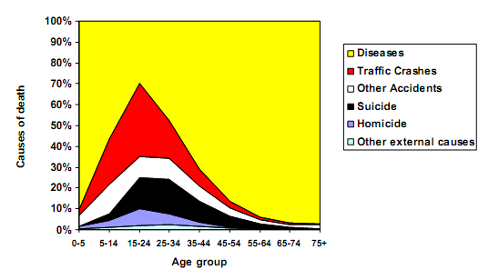
Figure 1.1 Relative Cause of Death by Age Range in OECD Countries
Source: World Health Organization Mortality Database.
Figure taken from OECD/ECMT Transport Research Centre (2006)

The OECD/ECMT Transport Research Centre (2006) report shows that, while overall road casualties have been reducing steadily over time (largely through improvements to highway and vehicle safety), the sizeable differential in fatality rates between young drivers and most other drivers is a common phenomenon throughout the developed world (see Figure 1.2). Furthermore, it shows that the bias of risk towards younger drivers that is found in the UK is typical amongst developed nations. Figure 1.3 gives another illustration of this bias: the number of young people killed while driving is much higher than their proportion of the population.
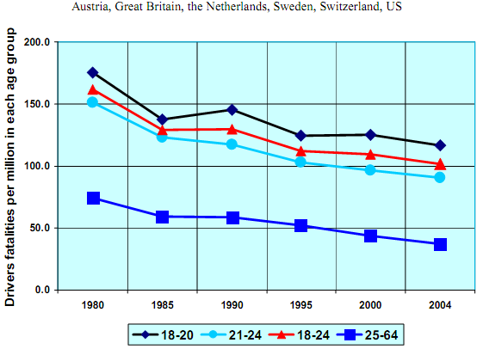
Figure 1.2 Driver Fatalities per Million Population for Different Age Groups, Over Time
Source: International Road Traffic and Accident Database (IRTAD)
Figure taken from OECD/ECMT Transport Research Centre (2006)

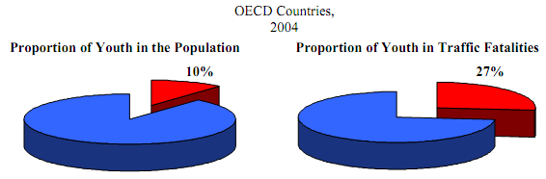
Note: “Youth” refers to people between the minimum driving age and age 24.
Figure 1.3 Proportion of Young People in the Population and in Driver Fatalities
Source: IRTAD
Figure taken from OECD/ECMT Transport Research Centre (2006)

For the year from which data are presented in Figure 1.3, i.e. 2004, the imbalance in Great Britain was slightly more extreme: 29.8% of driver deaths were persons aged 17-24 but that age range represented only 10.2% of the population; a ratio of 2.9 to 1 (OECD/ECMT Transport Research Centre, 2006). However, if young driver deaths are related to the population of licensed drivers rather than the population as a whole, the situation is more alarming still. As Table 1.1 shows, from 1992 to 2004 in the UK annual deaths of drivers aged 17-20 remained fairly constant while the numbers of full driving licence-holders in that age range dropped dramatically. Consequently, the rate of deaths per 100,000 full licence-holders aged 17-20 almost doubled over the period, from 12.6 to 22.6.

Table 1.1 Fatality Rates for Licensed Car Drivers Aged 17-20
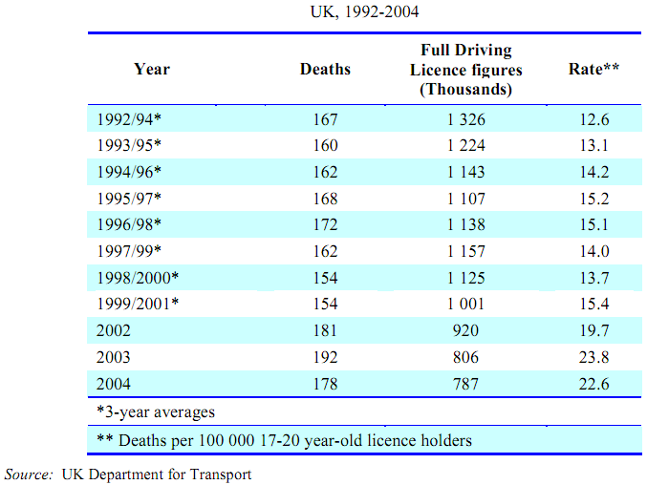
Table taken from OECD/ECMT Transport Research Centre (2006)

The latest figures from the Department for Transport (2011) show that in 2010 over 85% of men aged 30-69 held a full driving licence but only 35% of male 17-20 year-olds did so. For women the rate of full licence-holding was over 75% in the age range 30-59 but only 34% in the age range17-20. In fact, a higher percentage of women aged over 70 (41%) held a driving licence than young women under 21. The percentage of male licence-holders over 70 (78%) was more than double that of their counterparts in the 17-20 age group. It is reasonable to assume that fatalities are actually being held down by the relatively low rate of young driver licensing, which is largely attributed to the cost of learning to drive, and insuring and running a car (Department for Transport, 2011).
The figures presented so far have been restricted to driver fatalities. If we open up the examination of road risk and take Killed or Seriously Injured (KSI) casualties for all types of road user, the latest full analysis available from the Department for Transport (Chowdhury and Kilbey, 2010) provides the chart shown in Figure 1.4.

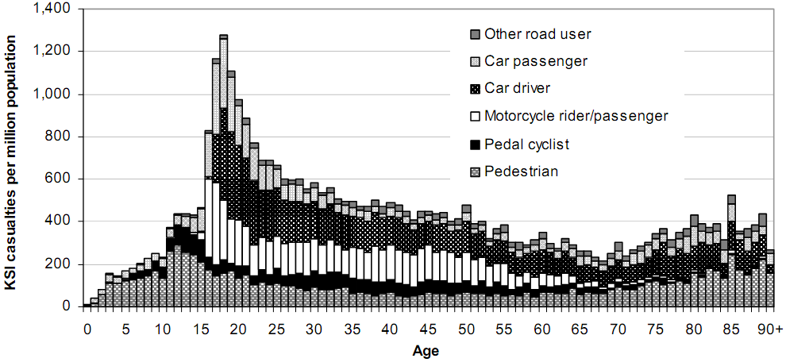
Figure 1.4 KSI Casualties per Million Population Rates by Road User Type and Age: 2009
Source: DfT
Figure taken from Chowdhury and Kilbey, DfT (2010)

Figure 1.4 indicates that the likelihood of being killed or seriously injured on the road is highest for young people in their late teens or early twenties, and at a minimum for road users in their late sixties (before rising again in old-age, largely through an increase in pedestrian casualties). The chart shows that the casualty rate (related to population rather than a measure of exposure such as distance driven) for 18 year-olds is around six times higher than for 68 year-olds. Half a century makes quite a difference. It will be noted that most of the casualties around the peak region occur while in or on motorised vehicles (pedestrian and cyclist casualties peak in the early teens). Motorcycle KSI casualties are highest for 16 and 17 year-olds but from the age of 22 motorcycle casualty rates are fairly constant until they start tailing off above 50 years of age. The car driver casualty rate is highest for 18 year-olds but then there is a fairly steady reduction over the next five decades. It is the car passenger casualty rate that peaks most sharply, with the highest rate at the age of 17. This, too, is linked with young drivers: Clarke et al. (2007) found that, in fatal crashes, there is a strong correlation between the ages of passengers and the drivers with whom they are travelling, with passengers tending to be slightly younger than their drivers.
Young drivers are more likely than older drivers to be involved in fatal or serious crashes in which occupants in their own vehicle or other road users are casualties (Hopkin, 2008; Clarke et al., 2002; Clarke et al., 2007; Chowdhury and Kilbey, 2010). The numbers of casualties linked to young drivers vary between studies. The results of an analysis by SWOV, the Dutch national road safety research institute, are shown in Table 1.2.
Table 1.2. Distribution of Fatalities and Serious Injuries Resulting from Young Driver Crashes
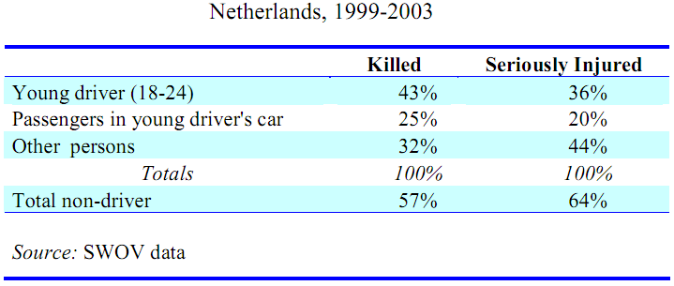
Table taken from OECD/ECMT Transport Research Centre (2006)
Analysis by Chowdhury and Kilbey (2010), which uses UK data and addresses only fatalities and not serious injuries, indicates a higher rate of non-driver fatalities than the Dutch research. As Figure 1.5 shows, fatalities classed as other casualties (that is, occupants of other vehicles, cyclists or pedestrians, and not occupants of the young driver’s own vehicle) have, over time, matched or exceeded young car driver fatalities, with fatalities amongst young drivers’ passengers averaging about 70% of the driver fatalities.

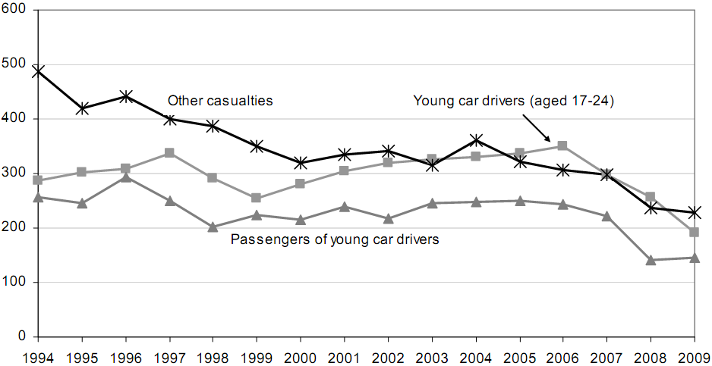
Figure 1.5 Reported Fatalities in Accidents Involving Young Car Drivers
(Aged 17 to 24) in the UK, 1994-2009
Source: DfT
Figure taken from Chowdhury and Kilbey, DfT (2010)

According to Chowdhury and Kilbey (2010, p. 25): “Fatalities in reported accidents involving young car drivers [17-24] accounted for 25 per cent of all road deaths in 2009.” A Freedom of Information request to the Driver and Vehicle Licensing Agency revealed that in 2009 only 2.9 million out of 34 million full driving licence holders fell into the age range 17-24. Thus, 8.5% of licence holders were involved in 25% of road fatalities (of course, this calculation does not take into account any unlicensed drivers who were involved in fatal crashes).
The threat that young drivers impose on other road users is confirmed by research in the USA by Evans (2004). He used data from the Fatality Analysis Reporting System (FARS) from 2000-2002, for incidents in which single vehicles hit and killed pedestrians without injury to the drivers, and plotted the pedestrian fatalities against the ages of the drivers involved, rather than the ages of the pedestrians. He was actually testing the hypothesis that elderly drivers pose a threat to others, but his conclusion was:
The number of pedestrians killed versus the gender and age of the involved driver shows that the main threat to other road users is overwhelmingly from young drivers. Even after adjusting for the fewer numbers of older people in the population, it is still the young who pose the greatest threat to other road users.
(Evans, 2004, p. 156).

2 Gender and Driver Risk
The “young driver problem” as it has previously been presented can be more accurately described as predominantly a young, male driver problem. Young, male drivers make by far the greater contribution to all of the fatalities and serious injuries that have so far been presented as attributable to young drivers in general. Figure 1.6, based on data from OECD/ECMT Transport Research Centre (2006), shows the distribution of driver fatalities in the population by gender and age (rate per million in each age group). The expected peak in fatalities is present in the younger age groups but it should be noted that the differential between male and female is maintained across the age ranges; at any age, the male fatality rate is around three times higher than the female rate.

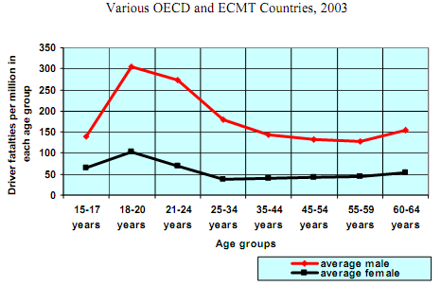
Figure 1.6 Driver Fatalities by Gender and Age, per Million Population
Source: OECD/IRTAD
Figure taken from OECD/ECMT Transport Research Centre (2006)

Partly, the difference in fatality rate by gender in the population can be explained by the fact that men tend to drive more than women. But women’s crash rate per mile may be higher than men’s. Williams (1996) found that, amongst the youngest (16 years-old) drivers in the USA, females drove half the mileage of males but had a per-mile accident rate that was a third higher. Ryan et al. (1998) in an Australian study found that female drivers had a very slightly higher crash involvement (adjusted for exposure by distance) than male drivers across most age groups but crash rates were essentially the same over the age range 17-29 (see Figure 1.7). McKnight and McKnight (2003) noted the higher crash rate per mile of females who drive less than males, but found similar crash rates between male and female drivers at ages where the annual mileage of the sexes becomes similar.

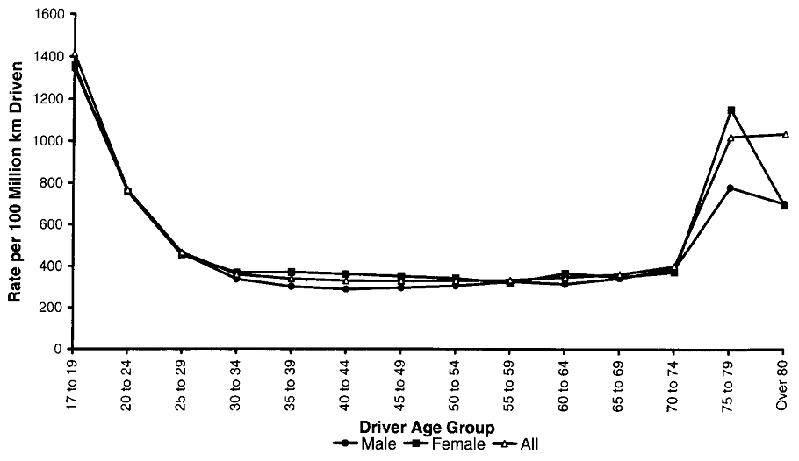
Figure 1.7 Driver Crash Involvement by Age and Gender, Western Australia 1989-1992
Source: Australian Bureau of Statistics and WA police crash statistics
Figure taken from Ryan et al. (1998)

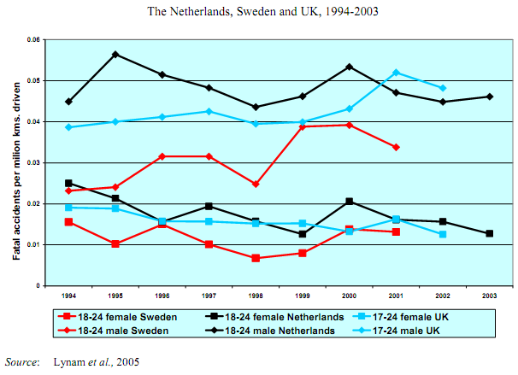
Figure 1.8 Involvement in Fatal Crashes of Young Male and Female Drivers per Million Kilometres Driven

Figure taken from OECD/ECMT Transport Research Centre (2006)

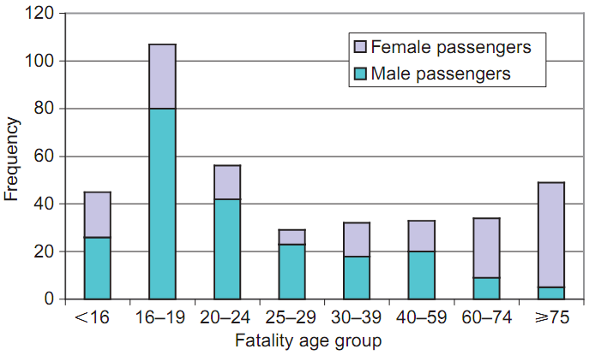
Figure 1.9 Passenger Fatalities By Age and Gender
Source: data from 10 UK police forces; sample of 1185 fatal crashes 1994-2005.
Figure taken from Clarke et al. (2007)
The foregoing examination of the high risk of young males is of particular relevance to this study because the gender bias in non-officer ranks in the Army is 92.9% male (latest available figures, 2006; Ministry of Defence website).

3 Being in the Army; Effect on Driver Risk
Defence Analytical Services and Advice (DASA) publish annual statistics of deaths in the regular UK Armed Forces, together with trends over a ten year period. In these reports, the term “road traffic accident” or similar is not used, the reason being that Armed Forces crashes may take place off paved roads and may not involve traffic. Instead the term “land transport accidents” is used. Any other fatal accidents, whether they are related to forms of transport other than on land or any other form of accidental death, are totalled together under the category of “other accidents.” Causes of death are recorded for all military personnel regardless of whether they occurred on duty or off duty.
For most of the last ten years, land transport accidents have been the leading cause of death in the regular UK Armed Forces, only being surpassed by death by hostile action since 2007 (because of the substantial increase in numbers of servicemen killed in action in Afghanistan). Three aspects of land transport accidents are of particular interest to this study: how fatalities in the Army compare with the other services; how the Army fatality rate compares with that for members of the UK general population of comparable age and gender (which gives the Standardised Mortality Ratio, SMR); and where and when the fatalities occur (on or off the public road, and on or off duty).
Regarding the first of these comparisons, figures from the 10-year trends published by DASA have been plotted on the chart shown in Figure 1.10. It should be noted that absolute numbers of deaths are not recorded but that fatality rates are expressed as fatalities per 100,000 of the UK Armed Forces population. In this manner, the three services may be directly compared even though they differ in size. It will be noted that for eight of the ten years the Army had the highest fatality rate, and in six of those years it was highest by quite a large margin.

Figure 1.10 Comparison of Land Transport Accident Fatality Rates for Army, Navy and RAF 2001-2010
Source: Deaths in the UK Regular Armed Forces 2010 (DASA, 2011)

Before examining the Army’s Standardised Mortality Ratios (SMR), an explanation of how these are calculated is taken from the “Methods” section of Deaths in the UK regular Armed Forces 2010 (DASA, 2011) and reproduced below:
To enable comparisons with deaths in the UK population, Standardised Mortality Ratios (SMR), adjusted for age, gender and year, were calculated. An SMR is defined as the ratio of the number of deaths observed in the study population to the number of deaths expected if the study population had the same age- and gender-specific rates as the standard population in each specific year multiplied by 100 by convention. An SMR over (or under) 100 indicates a higher (or lower) number of observed deaths than expected (based on standard population rates). An SMR of 100 implies that there is no difference in rates when comparing the UK Regular Armed Forces population with the UK population. [Italics in original version]
(Defence Analytical Services and Advice, 2011)
For some causes of death, the Armed Forces SMRs are well below 100; for example, the likelihood of service personnel dying from disease-related conditions has, over time, been only 20-30% of the rate in the general population. But this advantage is not maintained when road crashes are examined. Within the UK Armed Forces as a whole, the SMR for land transport accidents for the year 2010 was 210. Looking at the individual services, we see that the SMR for the Army was 271 (n = 28, 95% CI: 180-391), for the RAF 145 (n = 5, 95% CI: 47-338) and for the Navy 90 (n = 3, 95% CI: 19-262). These SMRs tell us little for just one year, because the samples are small (hence the very wide 95% confidence intervals). It is more reliable to look at longer-term trends. Over the last ten years, 2001-2010, the mean land transport fatalities SMR for the Army has been 234, for the RAF 156 and for the Navy 160. Therefore, during that period, Army personnel were, on average, 2.34 times more likely to be killed in road traffic crashes than was expected of people of the same age and gender in the general UK population. When it is appreciated that, in the general population, young males are by far the most at risk on the road, the extra risk associated with serving in the Army is a very disturbing statistic.
In Figure 1.11, the DASA’s ten year SMR figures for the Army’s land transport accidents has been plotted alongside the SMRs for other fatal accidents involving Army personnel, with the reference value of 100 indicated for the UK population, adjusted for age and gender to match the Army population. The two SMR plots show the Army’s performance in managing other accidents in comparison with its land transport accident record. It can be seen that, until 2007 (apart from 2006), accidental death (other than by road crashes) was more likely in the Army than in the UK population but, since then, the Army has improved safety in this area and maintained that improvement, so that current fatalities are a little over half the UK norm: the SMR for 2010 was 54, and the mean for the last three years was also 54. In contrast, the SMR for land transport accidents over the last 10 years has never been below 146 and has been as high as 284.

Figure 1.11 Standardised Mortality Ratios for Land Transport and Other Accidents in the British Army, 2001-2010
Source: Deaths in the UK Regular Armed Forces 2010 (DASA, 2011)

The DASA document Deaths in the UK Regular Armed Forces 2010 is very useful in that it shows standardised mortality ratios but it does not distinguish between on-duty and off-duty fatalities. Another DASA document, Health and Safety Incidents among MoD Personnel 2009/10, does make such a distinction but only for the whole of the UK Armed Forces; it is not possible to separate out Army statistics. It is difficult to correlate the two documents because the reporting periods differ (one uses calendar years while the other uses financial years), but by looking at ten year totals, any inaccuracies may be minimised. In the latter document, work-related, on-duty deaths on the public road are recorded as “road traffic accident” and any fatalities that involve motor vehicles on military property “inside the wire” are recorded as “land transport accidents” (each “accident” recorded refers to an individual’s death and not to an incident that may have resulted in multiple fatalities; thus a crash in which four soldiers died would be recorded as four accidents). Over the period 2000/01-2009/10 there were 83 road traffic accidents and 14 land transport accidents; a total of 97 vehicle-related deaths. During the period 2001-2010 there were 480 vehicle-related deaths in the Armed forces as a whole. This indicates that about 80% of the military personnel who die in road crashes do so while off-duty. A sizeable portion of those are killed while riding motorcycles. As Burdick (2010) reveals in an Army safety journal, between October 2009 and October 2010, twelve off-duty soldiers were killed in car crashes and seven off-duty soldiers died while riding their motorcycles. It is difficult to establish exactly what proportion of total Army road deaths these particular off-duty fatalities represent because they are taken from yet another different reporting period, but there is nothing to suggest that the 80% off-duty fatality rate for the Armed Forces as a whole does not also apply to the Army.
Taking all of this into account, it may be seen that young soldier drivers are probably involved in, and perhaps responsible for, hundreds of fatal and serious injuries to themselves and members of the general public every year. In view of this, the high driving risk of young soldiers is more than just a serious concern for the Army; it is a serious concern for society as a whole.

4 Army Category B (Car) Driver Training
Driving is an essential skill in many roles within the modern Army. Even where soldiers are not engaged in a primary driving role they may be required to drive in emergencies or as temporary back-up. For example, field medical personnel other than primary ambulance drivers need to be able to drive in case the normal driver becomes a casualty in action. Yet, largely because of their typical age on entry, most new recruits do not hold a driving licence. For these reasons, it is common to provide a standard Category B (car driving licence) driver training course immediately after Phase 1 Initial Training on Entry (otherwise known as Soldier Training) for the majority of new recruits. Hundreds of soldiers every year also receive further driver training (as part of Phase 2 Initial Specialist Training or at intervals throughout their career) to equip them to drive a wide range of specialist vehicles including large goods vehicles and tracked vehicles such as battle tanks and to obtain extra vehicle category entitlement on their driving licences.
Because of the need to train such large numbers of drivers and in line with most Army training, which is of fixed duration rather than open-ended, the normal Category B training course is condensed into two weeks; the first week to prepare for the theory test and the second week to prepare for the practical test. Actual driving time on the road during the course for each trainee may be only around 20 hours. It is usual to allow candidates three attempts at the driving test.

5 Risk Factors and Countermeasures

5.1 Experience
There is an inverse relationship between driver risk and driver age: risk reduces as age increases. But what is driving this reduction; is it an effect of age and “maturity,” or is it a function of the accumulation of experience? Research indicates that the answer is: both—but one matters more than the other. Citing studies from Great Britain (Maycock et al., 1991; Forsyth et al., 1995; Maycock, 2002a, 2002b), Canada (Cooper et al., 1995; Mayhew et al., 2000), Denmark (Carstensen, 2002), Norway (Sagberg, 2000), Sweden (Gregersen et al., 2000), Germany (Schade, 2001), Australia (Howard, 2004; VicRoads, 2005) and the Netherlands (Vlakveld, 2004), the OECD/ECMT Transport Research Centre (2006) reports widespread agreement amongst the researchers as follows:
Results have illustrated that there is a sharp decrease in crash liability during the first few years of driving, mainly associated with experience rather than age. In several analyses of month-by-month crash statistics after licensing, it has been shown that initially very high crash involvement decreases rapidly during the first half year of driving... Risk is lower when one begins driving later, although it also drops off quickly as soon as one begins driving. [Author’s italics]
OECD/ECMT Transport Research Centre (2006, p. 36)
The greatest reduction in crash risk comes at the very beginning of a novice’s solo driving experience; studies typically report a reduction in risk of 40-50% over the first 8 or 9 months but it takes about 2½ years before crash risk settles into a very slow and steady decline. The reduction in crash risk is paralleled by the reduction in a performers’ error rate as skill is developed through practice. The initially fast and then progressively slower rate of change of the crash risk (i.e. the error rate) may be explained by Hull’s (1943) proposal that learning and “Habit Strength” develop exponentially with practice (cited and discussed by Groeger, 2000). In an exponential progression, if it takes, say, 9 months for the initial crash rate to reduce by 50%, then the residual risk will halve again over the next 9 months (to 25% of the original level), then halve again over the next 9 months (to 12.5% of the original level) and so on. In practice, the rate of reduction tends not to be truly exponential (if it were, the risk would eventually approach zero) but tends to slow further as the personal risk level approaches a plateau. A similar effect is found with regard to the initial crash rate upon starting to drive solo in relation to age. The initial crash risk is progressively lower for each year after the minimum driving age that a novice driver becomes licensed. This effect is greater at younger ages than it is as age advances. It is similar to the quasi-exponential drop in individual risk but much more gradual; Vlakveld (2004) found that if drivers became licensed at age 21, their initial crash risk was about 25% lower than the initial crash risk of 18 year-olds, but those who started driving solo at 18 had lost about 66% of their crash risk by the time they were 21. Vlakveld (2004) also found that the rate and total amount of individual reduction of crash risk are related to age: the initial fall in risk is more pronounced at younger ages, but this may because it is higher in the first place; and those drivers who are youngest when they start driving may eventually attain a lower level of crash risk than those who start driving later in life. Figure 1.12, taken from Vlakveld’s (2004) study, shows all of these effects.

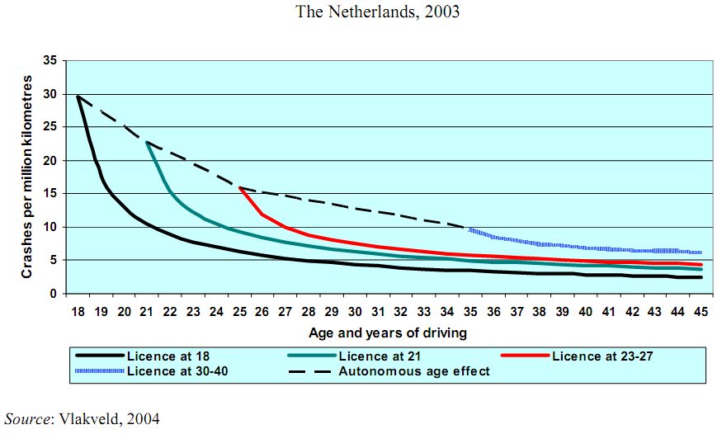
Figure 1.12 Age and Driving Experience—Crashes per Million Kilometres Driven for Drivers Who Attain Licences at Age 18, 21, 23-27 and 30-40
Figure taken from OECD/ECMT Transport Research Centre (2006)

The difficulty with the issue of driving experience is that it is a Catch-22 situation: in order to reduce risk one has to gain experience but, while gaining experience, one is exposed to high levels of risk. There seems to be widespread acceptance that this is a normal and inevitable condition and, in the case of young men especially, being at a high risk of crashing while gaining driving experience may even be regarding as a “rite of passage” (Ward et al., 2005). The acceptance of the situation is further reinforced by the older generation (perhaps simply because they went through it themselves) when they advise novices, “You only really start to learn to drive after you’ve passed your test.” In essence, this statement is regrettably mostly true for many but only because it is possible to pass a driving test with just a rudimentary knowledge of driving and a modicum of ability, which may be gained through minimal experience (clearly the driving test does not weed out the ill-prepared, or we would not see such a high initial novice crash rate).
One way in which the dangers of inexperience may be reduced is to increase the time spent accumulating experience under minimum-risk conditions, preferably before the driving test. It is known that the crash rate for learner drivers while under supervision is very low (Williams et al., 1997; Gregersen et al., 2000; Mayhew et al., 2003). The contrast in crash rates over the first 24 months of holding the equivalent of provisional or full driving licences is shown in Figure 1.13.

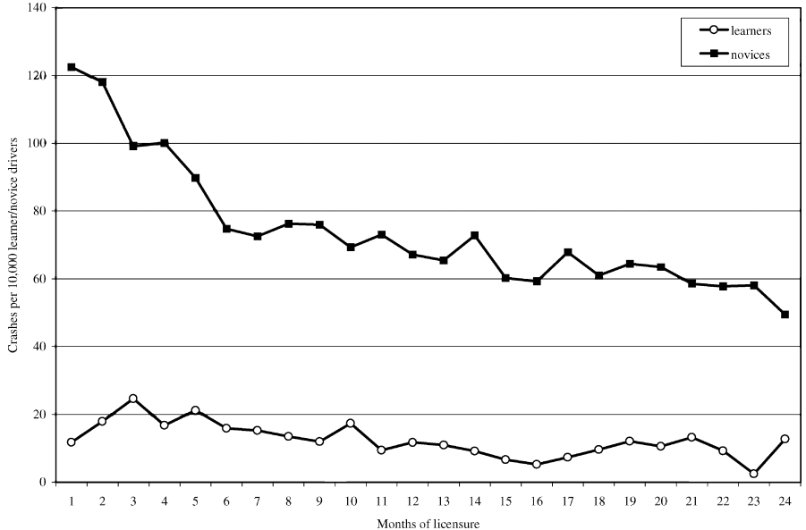
Figure 1.13 Crash Rates By Licence Status and Months of Licensure
Source: Driver records and crash data, 1990-1993, Nova Scotia, Canada
Figure taken from Mayhew et al. (2003)
Increasing the time spent learning to drive is an obvious solution and one that has proven to be effective (Gregersen et al., 2000) but it is difficult to achieve in practice unless it is encouraged through legislation. This is the thinking behind the adoption of extended learning periods (as an alternative to graduated driver licensing) in countries such as Sweden, Norway, France and Belgium, where the minimum age to drive on the road as an accompanied learner is below the minimum licensing age. But in the UK, where there is no such age gap between learning and licensing, there is a strong commercial demand for training that will enable customers to pass the driving test in the shortest possible time, at minimum cost. While a short length of training may satisfy commercial objectives, it is associated with a detrimental effect on road safety; that is, those who prove to be most at risk after licensing are typically those who had the shortest length of training. “The fact that young male drivers are the group who most readily pass the driving test might be cause for concern, when it is realised that it is this very same group that has the highest fatality rate” (McKenna, 2010, p. 7). Within the Army, many recruits receive as little as 20 hours of behind-the-wheel training time, which is less than half the minimum recommended by the Driving Standards Agency.
If more experience can be gained while the risk is being controlled, as it is while young drivers are being accompanied by experienced drivers, then we may expect to see a reduction in the initial level of risk when young drivers take to the roads on their own. This hypothesis was tested by Gregersen et al. (2000) in their study of the effects of reducing the minimum age for learner drivers from 17½ to 16 while retaining the minimum licensing age at 18, which was a reform implemented in Sweden in September 1993. Gregersen et al. (2000) report that the reduction in accident risk of those who took full advantage of the 2-year instead of 6-month early learning period was 40%. The 40% quoted was a figure reached after adjusting for confounding factors, such as differences in income and educational level of the family (drivers of higher socio-economic status and higher levels of education display lower risk on the road: Braver, 2003), in order to isolate the benefit that may be attached to changing the rules on learning to drive; the observed difference in crash rates was considerably greater (see Figure 1.14). The y-axis values of monthly accident rates have been taken from the graph (therefore they are smoothed values not actual observations) and put into Table 1.3 to allow for easy comparison.

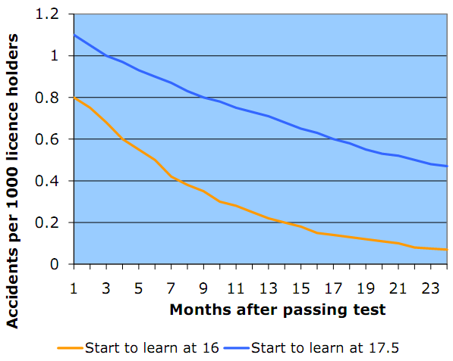
Figure 1.14 Monthly Accident Rate Comparison: Newly Licenced Drivers Who Started Learning to Drive at 16 Years-old v. Those Who Started Learning at 17.5 Years-old (Licensing Age in Sweden: 18 Years-old)
Source: Gregersen et al. (2000)
Figure derived from data published by Gregersen et al. (2000)

Table 1.3 Comparison of Injury Accidents Per 1,000 Licence Holders Per Month Between Newly Licenced Drivers Who Started Learning to Drive at 16 Years-old and Those Who Started Learning to Drive at 17½ Years-old
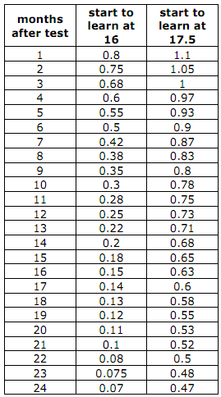
Source: Gregersen et al. (2000). Total study sample n = 243,823
Table derived from Figure 1.14

It can be seen from an inspection of Figure 1.14 and Table 1.3 that the initial solo crash rate of the 16 years-old starters was 73% of that of the 17½ years-old starters. A more significant way of expressing the difference is that the crash rate for the 16 years-old starters, as soon as they started driving solo, was the same as the 17½ years-old starters after they had been licensed for 9 months. So, effectively, the early starters had gained 9 months of safety. The reduction in crash rate for the early starters was steeper than for the 17½ years-old starters. After a little over 6 months, the younger starters reached the crash rate that the older starter group took 24 months to reach. After 24 months the crash rate of the early starters was only 15% of those who started later. In fact, some of these figures are familiar from the earlier discussion of experience: the difference in the initial crash rates between the two study groups when they became licenced at the age of 18 was very similar to the difference in initial crash rates that Vlakveld (2004) found between those drivers who qualified at 18 and those who qualified at 21; also, the rate of reduction in risk of the 16 years-old starters is actually an exponential progression (it halves every 7 months) in line with Hull’s (1943) proposal (the drop in risk for the later starters was more linear).
It seems likely that the differences that Gregersen et al. (2000) observe have little to do with age and much to do with the amount of pre-test practice. The mean amount of practice for the younger starters was 117.6 hours whereas the mean of means for the two groups of later starters was only 44.5 hours, a difference of 2.6 to 1. Gregersen et al. (2000) attribute the marked improvement in safety performance from the longer practice time to the theory of skill acquisition (Rasmussen, 1984) in which behavioural control and the skill acquisition process moves, over time, through three levels: knowledge based; rule based; and skill based. The effect of extended practice is that:
This development towards the skill based level makes it possible to shift more of the attention and decision making from the primary driving task to the driving environment, other road users etc. and makes it possible to predict the behaviour of other road users and evaluate hazards in traffic.

(Gregersen et al., 2000, p.26)
Studies in the UK show amounts of pre-test driving increasing over time. Respondents to the survey that formed the basis of the Cohort II report (Wells et al., 2008) had a mean total of 67 hours of driving (47 hours of professional training and 20 hours of practice with friends or family) before passing the driving test. This compares with a mean total of 49 hours in the earlier study, Cohort I (Forsyth et al., 1995). While the mean pre-test driving time for all learners is likely to be below the Cohort II figure, it is unlikely to be as short as the Army’s current provision in initial driver training. It has been mentioned in Section 1.2 that Army training courses tend to be fixed in length rather than open-ended. In the civilian world of learning to drive, learners tend to keep buying training and practising with friends and family until they think they are capable of passing the driving test (open-ended learning).
There is a need to recognise that time and experience is not necessarily the same thing: the quality of experience is as important as the quantity. By providing a fuller and more effective learning experience for the novice driver, more of the essential survival skills may be developed during the learning period and more situations may be encountered and rehearsed before going solo, instead of meeting them later, unprepared and alone.

5.2 Typical Young Driver Crashes
The crashes in which young drivers are involved tend to have more serious consequences than the crashes of older drivers. There are two main reasons for this. Firstly, the kind of crashes they have often involve high speeds. Numerous studies (e.g. Clarke et al., 2002, 2005; Clarke et al., 2007, 2010; Ward et al., 2005; OECD, 2006) have found a bias amongst young drivers towards loss-of-control crashes, which are often linked with excessive speed and often occur on bends. The high risk of injury comes from the vehicle’s subsequent impact with a roadside obstacle (for example, a tree) or oncoming traffic, or from overturning. The clear links between age and speed-related crashes are illustrated in Figure 1.15; and between age and bend crashes in Figure 1.16. (Note that the cases at the left end of the x-axis in both figures apply to illegal, underage drivers.)

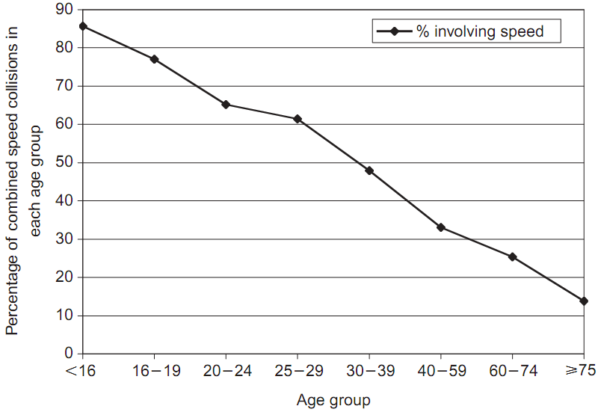
Figure 1.15 Pattern of Percentages of Speed-Related Fatal Cases By Driver Age
Source: data from 10 UK police forces; sample of 1185 fatal crashes 1994-2005.
Figure taken from Clarke et al. (2007)

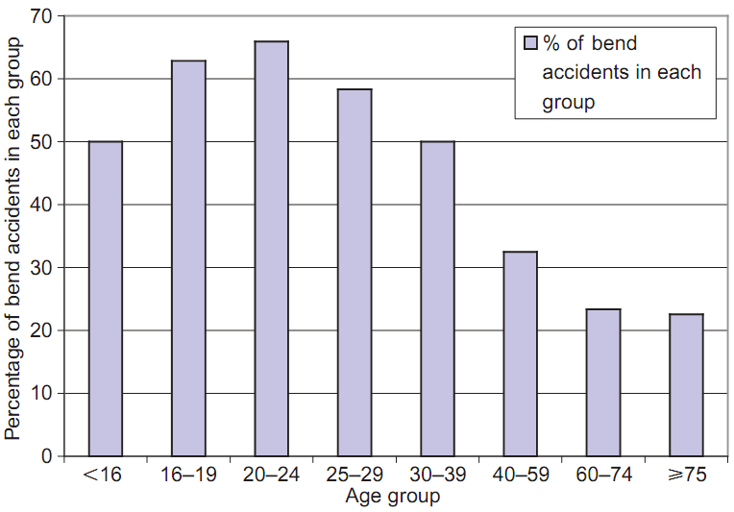
Figure 1.16 Percentage of Bend Accidents By Driver Age for At-Fault Drivers
Source: data from 10 UK police forces; sample of 1,185 fatal crashes 1994-2005.
Figure taken from Clarke et al. (2007)

The second reason that young drivers and their young passengers tend to be more vulnerable to injury than their older counterparts is that they tend to be less well protected: they are more likely to travel in older, smaller cars (Evans, 2004, p. 63-97, demonstrates in detail how smaller vehicles have higher crash injury risk than larger ones) that have fewer primary and secondary safety features (respectively, dynamic features such ABS or ESC, and passive features such as seat-belt tensioners and airbags); and they have the lowest rate of seat-belt wearing. Clarke et al. (2007) found that only 50% of the fatalities they investigated had definitely been wearing a seat-belt (and 16% of cases were either “unknown/unrecorded” or “not applicable”—in the rear seats of older cars not fitted with seat-belts) and that there was an inverse relationship between occupants’ failure to wear seat-belts and the drivers’ age. Figure 1.17 shows this relationship (note that the very high percentage of non seat-belt wearing in the youngest group applies, again, to illegal, underage drivers).

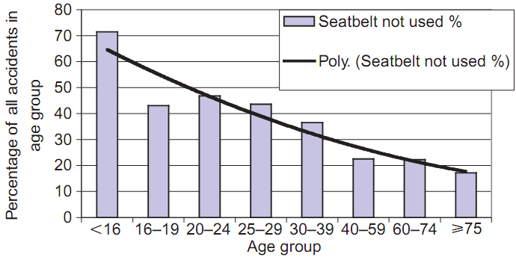
Figure 1.17 Percentage of Fatalities Not Wearing Seat-belts by Driver Age
Source: data from 10 UK police forces; sample of 1185 fatal crashes 1994-2005.
Figure taken from Clarke et al. (2007)

For drivers under the age of 30, over half of the fatal accidents were caused by loss of control on a bend or curve. As a whole, these fatal accidents occurred over four times as often on rural roads as they did on urban roads. Over half (57%) occurred during the hours of darkness... There were approximately ﬁve times as many male drivers at fault in this fatality class as there were female drivers at fault.
(Clarke et al., 2010, p. 766)
The quote from Clarke et al. (2010) sums up typical young, male driver crashes: going out of control (often through excessive speed); at bends; often with no other vehicle involved; usually rural roads; at night. What they do not mention in the quote above, but cover elsehere in their study (as do Ward et al., 2005), is that there are often passengers in the car, who tend to be of similar age to the driver. The particular circumstances of serving in the Army may contrive to make such a combination of crash factors more likely.
.

5.3 Brain Development
Much of the research into the risky, young driver phenomenon falls into the rather “soft” science of social psychology, in which conclusions are often tentatively drawn from indirect data such as questionnaire responses or large sample crash data. We are on slightly more solid ground in the field of cognitive psychology, where we enter the laboratory, but then the difficulty is usually in being able to determine to what degree laboratory results may be applicable to the real world (much of the use of driving simulators falls into this category). In the field of neurology we find the most solid science available to the driver behaviour and traffic accident researcher: we can put drivers’ brains (complete with the rest of the drivers) into brain scanners and look for significant differences. And it is neurology that has given us one of the most significant findings of recent years, and one of the most productive areas for the development of remedial interventions: young drivers have brains that are different from those in the heads of older drivers.
The area of the brain that is receiving most of the attention in relation to young drivers is the frontal lobe. Until very recently it was thought that the brain was fully grown when the rest of the body had stopped growing. Now it is known that brain development continues long after late adolescence. The last part of the brain to reach maturity is the prefrontal cortex, which is part of the frontal lobe, and this may not happen until around the age of 25 (Dahl & Spear, 2004). Interestingly, this is also the age when age-related influences on crash risk tend to fall sharply (Mayhew et al, 2003), a point not lost on motor insurers who commonly use the age of 25 as a cut-off point below which they may not offer cover on many vehicles. The significance of this for Army driver training is that most of the trainees do not have fully developed brains.
The sort of functions that are controlled by the prefrontal cortex and that are essential to safe driving are, for example, decision making, the ability to project future consequences, the ability to “walk in others’ shoes” or empathy (Isler et al., 2008). It is not unusual to find that young drivers’ risky behaviour is sometimes described in the research literature as reckless behaviour. But is it? Jonah (1986) points out that, “It is important to note that the use of the term ‘risk-taking’ does not necessarily imply volition.” The underdevelopment of the frontal lobes does help to explain some of the behaviour that older drivers would regard as reckless but that young drivers often simply do not appreciate as such (because their ability to perceive risk is immature). Reason (1990), in attempting to define the varieties of human error, makes a first split into intended actions and unintended actions. But this division rather assumes that it is clear that an error is intended or unintended. This is difficult to establish, particularly with regard to a form of error to which young drivers are particularly prone: distraction or inattention.
Prior to the 100-car naturalistic study (Klauer et al., 2006) it was thought that distraction, while significant, was present in a minority of crashes. Klauer et al.’s (2006) study found that almost 80% of all crashes and 65% of all near crashes were immediately preceded by “the driver’s looking away from the forward view,” that is, inattention on the road. Furthermore, the rate of crashes and near crashes related to inattention was four times higher for 18–20 year-old drivers than it was for drivers aged over 34. But is distraction unintentional risk-taking or does the driver intentionally allow himself to be distracted? Klauer et al. found, in most cases, the latter: the driver initiated the action that involved removing his gaze from the forward view. But if the driver does not appreciate the dangers of his actions as well as an older driver does, is that really intentional?
It would be easy to be fatalistic and assume that this late development of the frontal lobes leads to inevitable risky behaviour from young drivers. But there is another recent discovery in the field of brain development that, if understood and utilised, helps to offset the weaknesses described above. That discovery is that the brain has plasticity: that is, individual parts of the brain may be moulded and expanded, and neural connections strengthened, in much the same way that muscle groups can be grown and shaped by specific load-bearing physical exercises (Doidge, 2007). And just as with muscle-building exercises, this is not just a matter of performing repeated actions but also of performing the right actions to achieve the desired outcome. It is possible that repeated e-learning trials help to develop executive functions that are critical to safe driving.

5.4 Situational Awareness and Hazard Perception
The key skills that appear to be weaker in young drivers than they are in older drivers (simply because, in the past, the only way to develop them was through experience) are situational awareness and hazard perception. The most commonly used definition of situational awareness comes from the originator of the term, Endsley (1988), who defines Situational Awareness (SA) as, “...the perception of the elements in the environment within a volume of time and space, the comprehension of their meaning and the projection of their status in the near future.” This concise definition gives the three key stages, in the order in which they must occur: perception; comprehension; projection. Or, colloquially, Have I seen it? What does it mean? What happens next? SA, it should be stressed, is a generalised process; it is about all-encompassing awareness of the situation in which the driver finds himself. In general, experienced drivers have a more highly-developed, “three dimensional” awareness of their surroundings than inexperienced drivers, who are more prone to the danger of “not seeing the wood for the trees.” One of the key skills of SA is effective visual scanning: looking at lots of different things rather than fixating on just a few, but looking at each for long enough to comprehend what it is. Traditional driver training tends to overlook this essential skill, as though novice drivers should instinctively know how to do it.
Whereas SA is generalised—get the whole picture, understand it, and appreciate how it will change—hazard perception is specific. It is now recognised that waiting for situational awareness and hazard perception to develop through the trial and error of experience is hazardous in itself. Consequently, in driver education there is now much attention being given to the development of these skills in safe environments. One of those safe environments is e-learning delivered through platforms such as the intervention used in the present study: DRIVE iQ.

6 DRIVE iQ e-learning
There is no doubt that e-learning will change the way we deliver training in our increasingly technologically-based Armed Forces. It has the potential to reduce residential training times, helping both to keep personnel in Front-Line Commands and reducing separated service.
(MoD, 2004, p. 13)

E-learning has various advantages over traditional forms of training but one of the most attractive is cost. Producing effective e-learning materials is far from cheap (so economy of scale comes into play by ensuring that a product has many users) but the delivery of e-learning incurs little cost, being self-directed and not requiring expensive equipment. Another of the advantages of e-learning is that the learning/practice sessions can be spaced. A minimum time can be set between sessions so that the student does not try to cram all the learning together, which has been found to be less effective (Groeger, 2000, p. 81)
DRIVE iQ is an e-learning suite of modules developed by a²om International Limited, a driver education software development company. It is delivered on-line via a special platform. All users have their own password and their progress through the programme is tracked and recorded. DRIVE iQ has many thousands of users: it is found in many schools, it is being used by the AA Driving School, and it is used in a scheme to re-educate young driving offenders, operated by Thames Valley Police.
DRIVE iQ is a platform of educational modules and online training exercises designed to improve knowledge, attitudes and skills in driving. It is based on 20 years of European research which lead to the Goals for Driver Education (Hatakka et al., 2002), a framework or structure upon which effective educational interventions may be based.

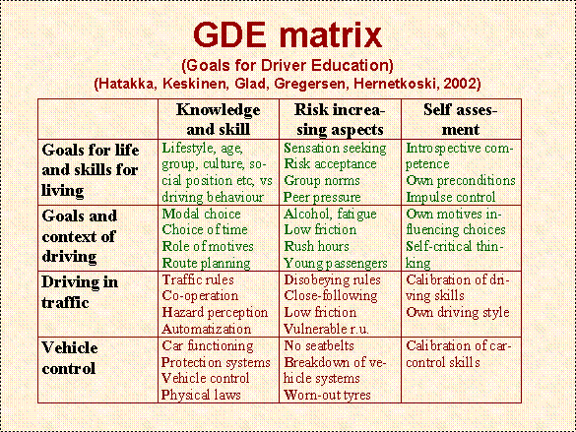
Figure 1.18 The Goals for Driver Education (GDE) Matrix

Unlike traditional driver training which tends to cover just car control and traffic procedures (the lower two, red levels in Figure 1.18), The GDE Matrix also covers higher level cognitive, culture and social factors (the upper two, green levels). The matrix spreads horizontally as well as vertically: traditional driver training tends to focus on just the knowledge and skills column, so it occupies the left-hand bottom corner, but the GDE matrix encourages students to be aware of and consider the risk-increasing aspects of driving (forewarned is forearmed), and to be aware of their own thoughts, emotions and behaviours through a process of self-assessment. DRIVE iQ covers all levels and columns of the GDE matrix.
One of the main functions of DRIVE iQ is to help users to develop situational awareness and hazard perception. It does this with video sequences shot in high definition video that have three rearward mirror views synchronized with the forward action. Part of a car’s interior is also visible in the foreground so that normal instruments (particularly the speedometer) are displayed in the field of view on screen. As well as being of much higher picture quality than the material used by the Driving Standards Agency in the Hazard Perception Test (HPT) that forms part of the theory test that all learner drivers must pass before being able to take the practical driving test, the user has a greater sense of being in the environment through having the rearward views and more peripheral view. Users develop their visual scanning skills and anticipation through interactive exercises in which, for example, as a hazardous situation begins to unfold, the action is frozen and the user is asked to anticipate what will happen next or what action it is appropriate to take.
The efficacy of DRIVE iQ has already been the subject of academic research prior to the present study. Isler et al. (2009) used it to compare the performance of novice and experienced drivers and then, after using its video-based training in hazard perception found that those who had been trained with the video material had attained a level of hazard perception that was equal to the experienced drivers (unlike the control novices who had not improved. af Wåhlberg (2010) examined the Thames Valley Police Young Driver Scheme, although he used questionnaires rather than hazard perception testing to judge the effect of the training material.

METHOD

7.1 Objectives
The original Cranfield University study was set up to assess the benefits of about ten hours of supplementary e-learning (using modules from the DRIVE iQ e-learning suite produced by a²om International Limited) as an intervention to increase hazard awareness skills amongst Army recruits undergoing their Category B driving licence acquisition training. The aims of the e-learning intervention are: to improve hazard awareness skills and attitudes to driving hazards and risks; to improve performance on the theory and practical driving test components; to reduce the overall cost to the Army of wastage within Category B driver training (wastage being defined as those trainees who do not qualify for full driving licences at the end of the training period). The longer-term aim is that, by broadening and deepening young soldiers’ initial driver education, they will be better equipped to face the dangers on the road and be less likely than their peers to be involved in road traffic collisions, with consequent reductions in the human and financial costs that such collisions inevitably entail.
The following objectives are tested:
- Do Larkhill recruits believe that the DRIVE iQ platform improved their knowledge of hazards and helped them with the learning to drive process?
- Does the DRIVE iQ platform improve attitudes to driving hazards and risks amongst the Larkhill group compared with the Minley group?
- Does the DRIVE iQ platform improve performance on the practical driving test components amongst the Larkhill group compared with the Minley group and thereby reduce the overall cost of wastage within CAT B driver training?

7.2 Participants
The participants took part in a quasi-randomised control trial. In a true randomised control trial, participants would be randomly selected from a pool to join either the experimental group or the control group. Neither the participants nor the researchers would know in advance to which group the participants would be assigned (and, ideally, neither would the participants know the role of their group after they had been assigned). Such an arrangement was impractical to implement in this case as the study had to be accommodated within normal Army practices and procedures. The selection of the participants was done, therefore, with opportunity sampling (so called because potential participants were available and the opportunity was taken to invite them to take part). The participants had all been allocated to take part in regular Category B driver training at either the Royal School of Artillery, Larkhill (the experimental group) or the Royal School of Military Engineers, Minley (the control group). It is normal Army practice to provide this training to recruits just after they complete their Phase 1 Initial Training on Entry (otherwise known as Soldier Training). Participants were not screened prior to selection, so their selection was random, nor was their identity known to any of the researchers at any time during the study. They happened to be passing through the two training schools during the trial, the period of which had been arbitrarily selected. Within the practical constraints imposed on the trial, everything was done to ensure that the participants were representative of typical participants in Army Category B driver training. All participants were given full details of the nature of the study and invited to take part, and they were free to drop out at any time. Participant information sheets for both experimental and control participants may be found in Appendix B and the subject consent form may be found in Appendix C.
The sample sizes were 128 in the RSA, Larkhill (experimental) group and 92 in the RSME, Minley (control) group. The age ranges were between 17-32 at RSA, Larkhill and 17-33 at RSME, Minley. However, approximately 70% of the participants’ ages in both groups fell within the anticipated range 17-20. The mean age for RSA, Larkhill was 19.82 (n = 128, SD = 3.203) and the mean age for RSME, Minley was 20.02 (n = 92, SD = 3.524). It can be seen from the small standard deviations that the ages were tightly clustered around these means.
Across the whole study cohort 92.7% of the participants were male, which is very close to the 92.9% of males in non-officer ranks in the Army as a whole (latest available figures, 2006; Ministry of Defence website). However, there was more of a male bias in the control group than in the experimental group: the RSME, Minley group comprised 91 male participants and 1 female, thus it was 98.9% male; while the RSA, Larkhill group comprised 113 male participants and 15 female, thus it was 88.3% male.
More than half of both groups had had some previous experience of driving cars or riding powered two-wheelers (PTWs) but the groups differed in the type and amount of training and/or practice they had had (see table below). Generally, the female participants had had much less previous experience than the male participants. No details were collected regarding educational background or attainment. The full demographic details that were collected from the study cohort of participants are given in Appendix A.

Previous experience of driving/riding motorised vehicles

RSA Larkhill RSME Minley

Any vehicle: 67%  Car driving experience: 53%  PTW riding experience: 41%  PTW only; no car: 14%  Both car and PTW: 28% | Any vehicle: 58%  Car driving experience 45%  PTW riding experience : 46%  PTW only; no car: 15%  Both car and PTW: 30%
Previous driver training and practice

RSA Larkhill RSME Minley

Car driving experience: 53% Professional instruction: 21%  Private practice only: 43%  Both professional instruction and private practice: 36% | Car driving experience: 45%  Professional instruction:7%  Private practice only: 49%  Both professional instruction and private practice: 41%
Motorcycle training and licensing

RSA Larkhill RSME Minley

PTW riding experience: 41%  Motorcycle training taken: 34%  Motorcycle licence held: 28% | PTW riding experience: 46%  Motorcycle training taken: 24%  Motorcycle licence held: 14%

7.3 Design and Procedure
The study used a mixed between and within-subjects, repeated measures design to investigate novice drivers’ perception of, and attitudes towards, risk and to determine whether the supplementation of basic, Army-delivered, Category B (car) driver training with a programme of e-learning that is intended to develop young drivers’ understanding of risk, situational awareness and hazard perception would produce an improvement in driving test performance. The control group received normal Army Category B (car) driver training (see Section 1.2), divided, as is standard practice, into two stages: stage 1 was a week of training to prepare for the driving theory test, at the end of which the theory test was taken; stage 2 was a further week of practical in-car training, after which the practical driving test was taken. The experimental group received the same provision for training and tests plus DRIVE iQ e-learning.
Three questionnaires were administered: (1) before Stage 1 training began; (2) after Stage 1 training and before taking the theory component of the driving test; (3) after Stage 2 training and before taking the practical component of the driving test. Details of the questionnaires may be found later in this section. Driving test results were furnished by RSA, Larkhill and RSME, Minley. The design of the trial is presented graphically in Figure 7.1.

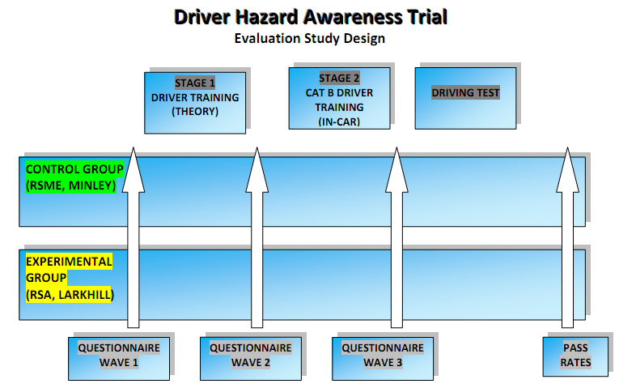
Figure 7.1 The Experimental Design of the Study

7.4. Questionnaires
Apart from eight items regarding DRIVE iQ feedback (see next section) in Questionnaires 2 and 3 completed by the RSA, Larkhill group only, the remainder of the content of the questionnaires was common to both groups. The first questionnaire, administered before training began, contained Section A to gather information on: service number (simply used for matching up samples in repeated measures); age; date of birth (also useful for matching up samples if the service number was hard to read); gender; and nine questions on previous driving/riding experience. Having collected all that information in questionnaire 1, in Questionnaires 2 and 3 Section A was abbreviated to just 4 items: service number, age, date of birth and gender. Section B items were informed by Dalziel and Job (1997) while also being based on the speeding subscale from Parker, Stradling and Manstead (1996) concerned with gathering opinions on the perception of risk (8 items) and attitudes towards some behaviours and policies (10 items). The responses to all items in Section B were indicated on 5-point Likert scales (either 1 = Not at all dangerous → 5 = Extremely dangerous, or 1 = Strongly agree → 5 = Strongly disagree). Section C contained two items on personal crash risk and that of peers (with responses marked on a 0-100% scale with 20% intervals). The full contents of the questionnaires are shown in Appendix B.

7.5 Statistical Analysis of Questionnaire Responses
All statistical analysis was carried out using SPSS 18. Before running any tests, the distributions of all relevant data were checked for normality. This was done using the Explore function in SPSS: descriptive tables were checked, particularly for skewness and kurtosis; Kolmogorov-Smirnov and Shapiro-Wilk tests of normality were run; normal Q-Q plots and detrended normal Q-Q plots were checked; histograms and boxplots were produced. All Kolmogorov-Smirnov and Shapiro-Wilk tests were highly significant (in nearly all cases p = .001), indicating that all distributions of the data were significantly different from normal distribution. The distributions of most data were found to be highly skewed, with participants’ responses clustered at one end or the other of the Likert scales. In a few cases the Standardised Skewness and Standardised Kurtosis lay within the acceptable range of +/- 1.96 but other assumptions of parametric data were not met.
Some data were transformed: the responses to ten statements in Questionnaires 1, 2 and 3 that had originally been coded from 1 = Strongly Agree to 5 = Strongly Disagree were transformed (1→5, 2→4, 3→3, 4→2 and 5→1) and the values recoded to read from 1 = Strongly Disagree to 5 = Strongly Agree. All analysis was then carried out on this partially transformed dataset. Descriptive statistics were run on all available questionnaire data: that is, the responses of participants in both the experimental group (RSA, Larkhill) and the control group (RSME, Minley) to Questionnaires 1, 2 and 3 (respectively, before any driver training had begun, after theory training, after practical training). There were no missing data for items in Questionnaire 1. Missing data in Questionnaire 2 were typically 2.3% for RSA, Larkhill and 16.3% for RSME, Minley. But RSME, Minley’s missing data for items in Questionnaire 3 typically ran at 57.6%, while it was only 3.9% for RSA, Larkhill. It was felt that the small remaining sample from RSME, Minley who completed Questionnaire 3 (only 39 participants) may not have been representative of the original sample of 92 participants from RSME, Minley. Therefore it was decided to do a full analysis of data from Questionnaires 1 and 2 only (pre- and post-theory training).
In view of the nonparametric data, the analysis was carried out with nonparametric tests. In order to examine between-group effects, the Mann-Whitney U test was used. Within-group changes were analysed by splitting the data file into groups (by Camp ID) and running Wilcoxon Signed-Ranks Tests. Clustered bar charts were plotted for each item, with 95% confidence interval error bars. In the interests of consistency, charts were edited as necessary so that all showed the full range of available responses (that is, 1 to 5) on the y-axis (the standard output from SPSS abbreviates the axes to show only the range of entered data, which may exaggerate the differences between samples).
For the experimental group only, the feedback on DRIVE iQ from Questionnaires 2 and 3 was processed by checking frequencies of responses using the Explore function of SPSS 18 and presented graphically in pie charts.

7.6 Driving Test Data
Results of practical driving tests were supplied by RSA, Larkhill and RSME, Minley. There was a wide range of responses and each was given a coding in the SPSS dataset to allow analysis. Codes used were as follows: 1 = Passed first test; 2 = Passed second test; 3 = Passed third test; 4 = Passed fourth test; 5 = Passed fifth test; 10 = Theory course only; no practical training; 90 = Withdrawn from practical training; no tests; 131 = First course failed three tests; second course passed first (fourth) test; 201 = Withdrawn from first course; second course passed first test; 202 = Withdrawn from first course; second course passed second test; 99 = Missing data. There was a lot of missing data with regards the pass rate for the practical driving test from RSME, Minley.
In order to make use of the valid driving test data that was available, an analysis was performed to see whether there was a relationship between previous driving experience and passing the practical driving test within three attempts. Two variables were re-coded into new variables to allow cross-tabulation. The responses to the question, “Approximately how many miles of driving practice have you had IN TOTAL outside your service training?” which was originally coded in the dataset from 0‒6, representing, respectively, none; 0-99; 100-199; 200-299; 300-399; 400-499; 500 +, was recoded into a new variable labelled “Previous experience” with values corresponding to just Yes (1) or No (0) The variable “Driving tests to pass,” which has 11 different possible values, was recoded into a new variable labelled “Pass within first 3 tests,” with a value of 1 corresponding to a test pass in 1, 2 or 3 attempts, and a value of 0 corresponding to all other responses. The results of the cross-tabulation are presented in the next section.

7.7 Specification of DRIVE iQ for the Trial
The DRIVE iQ e-learning was split into two stages, with each stage appropriate to the other training that the participants were taking concurrently. Thus Stage 1, used while the participants were being trained for the theory test, was focused on matters of risk awareness and the higher levels of the Goals for Driver Education, while Stage 2, which ran alongside in-car training for the practical driving test, was focused more on car control and traffic procedures but still included material intended to develop situational awareness and hazard perception. Prior to any individual study of DRIVE iQ, and at the start of their driver training course at RSA, Larkhill, the participants in the experimental group attended a two-hour, facilitated workshop and group discussion that was based on the DRIVE iQ module Anatomy of a Crash covering young driver risk factors as discussed in Section 1. The objective of this workshop was to develop recruits’ understanding of the consequences of a crash: that a crash affects not only the vehicle and the occupants, but also that it has far-reaching effects on friends and family.

Stage 1
Studied in parallel with theory test training
Access to the DRIVE iQ learning suite including the following topics:
Session 1
Driving Skills and Risk Alertness (animation)
Road Signs (animation)
Eye Scanning Tutorial (animation)
Eye Scanning Clips (video)
Session 2
Other Road Users Safety Margins (animation)
Collisions (animation)
Level Crossings (animation)
Hazard Perception Test Clips (video)
Session 3
Environmental Driving Environment (animation)
Overtaking (animation)
Managing Risk (animation)
Session 4
Responsibility and Self-evaluation Anticipation and Awareness (animation)
Motorways (animation)
Anatomy of a Crash (animation)
Risk Management Clips (video)
Session 5
Safe Driving Behaviour Vulnerable Road Users (animation)
Conditions (animation)
Further Clips (video)
The learning site also includes access to the DSA question bank.

Stage 2
Studied in parallel with practical, Category B driver training
Module 1 (1 hour) Controls (animation)
Moving Off Part 1 (animation)
Turning Into Side Roads (animation)
Emerging (animation)
A Five-question Assessment

Module 2 (1 hour) Crossroads (animation)
Roundabouts (animation)
Observation (animation)
A Five-question Assessment
Video Clips of Traffic Scenarios
Five Interactive Video Clips as an Assessment

Module 3 (1 hour) Moving Off Part 2 (animation)
Anticipation (animation)
Controlled Stop (animation)
A Five-question Assessment

Module 4 (1 hour) Meeting and Passing (animation)
A Five-question Assessment
Video Clips of Traffic Scenarios
Five Interactive Video Clips as an Assessment

Module 5 (1 hour)
The recruits were shown some video clips run twice, the second time showing the hazards that should be kept in mind and with some feedback. This was followed by 5-10 interactive clips as an assessment.

RESULTS
Results of the statistical analysis of the dataset compiled from questionnaire responses and from driving test results are presented in this section. DRIVE iQ feedback from the experimental (RSA, Larkhill) group only is presented first; then the results of the analysis of Section B and Section C questions 1 and 2 are examined; and finally the driving test results are compared. All of the results from the analysis are presented here.

8.1 DRIVE iQ Responses
Objective 1 set out to examine whether the experimental group indicated that they find DRIVE iQ e-learning to be an enjoyable and acceptable form of training, and that they appreciate the benefits inherent in such a form of training.
The participants in the experimental (RSA, Larkhill) group responded to 8 items in Questionnaires 2 and 3 in order to provide feedback on their experience of using DRIVE iQ. For each item, the responses of the whole group are presented in two pie charts, one for Questionnaire 2 (after theory training) and one for Questionnaire 3 (after in-car training). With the possible exception of the issue of the e-learning being considered to be enjoyable, the rest of the null hypothesis—that the users find DRIVE iQ e-learning not to be an acceptable form of training, and that they do not appreciate the benefits inherent in such a form of training—may be rejected.
The study aimed to investigate three objectives:-
- Do Larkhill recruits believe that the DRIVE iQ platform improved their knowledge of hazards and helped them with the learning to drive process?
- Does the DRIVE iQ platform improve attitudes to driving hazards and risks amongst the Larkhill group compared with the Minley group?
- Does the DRIVE iQ platform improve performance on the practical driving test components amongst the Larkhill group compared with the Minley group and thereby reduce the overall cost of wastage within CAT B driver training?

The analysis was conducted to address these three objectives in turn.

OBJECTIVE 1: DRIVE iQ Acceptability
The analysis for Objective 1 aimed to investigate whether Larkhill recruits believe that the DRIVE iQ platform improved their knowledge of hazards and helped them with the learning to drive process. To explore this research question, attitude questionnaires were administered after Stage 1 driver training (theory test) and just before taking the practical driving test at Stage 2 contained questions asking Larkhill participants. This period of time of training allowed the participants to become familiar with the DRIVE iQ platform and thereby to provide a response to several statements about various aspects and attitudes towards the DRIVE iQ platform.
The same eight questions were asked after Stage 1 and after Stage 2 driver training:-
- I enjoyed the DRIVE iQ on-line modules
- DRIVE iQ feedback helps to identify my weaknesses
- DRIVE iQ modules help me improve my driving performance in the vehicle
- DRIVE iQ modules improve my knowledge about hazards
- DRIVE iQ modules improve my knowledge about the risks of driving
- DRIVE iQ modules were not necessary for learning to drive
- DRIVE iQ modules were easy to use
- DRIVE iQ modules help me be a safer driver

DRIVE iQ Enjoyment
After undergoing their Stage 1 the majority of the participants (44%) agreed with the statement ‘I enjoyed the DRIVE iQ on-line modules’ (see Figure 8.1) but this was reduced to 26% at Stage 2 with most participants responding neither agree nor disagree (42%) (see Figure 8.2). This might reflect the stage of learning with participants concentrating on the practical component rather than DRIVE iQ.

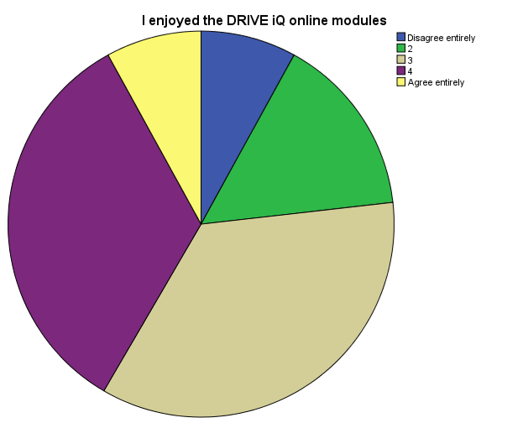

Figure 8.1: DRIVE iQ Enjoyment after Stage 1 Training

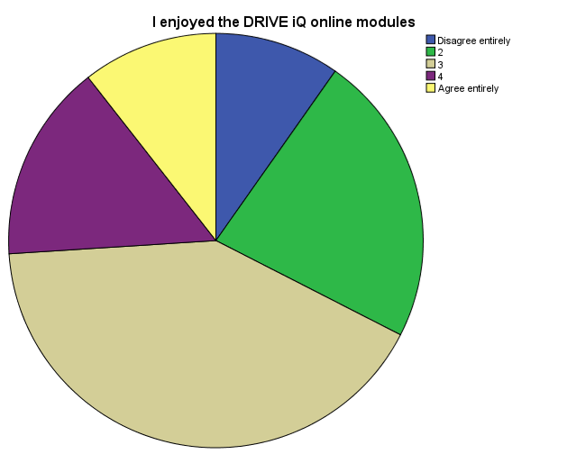

Figure 8.2: DRIVE iQ Enjoyment after Stage 2 Training

DRIVE iQ Identifies Weaknesses
After undergoing their Stage 1 driver training, Larkhill participants were asked whether DRIVE iQ feedback helped to identify their weaknesses. The majority of the participants (51%) agreed with this statement (see Figure 8.3) and a similar percentage agreed at Stage 2 (45%) (see Figure 8.4).

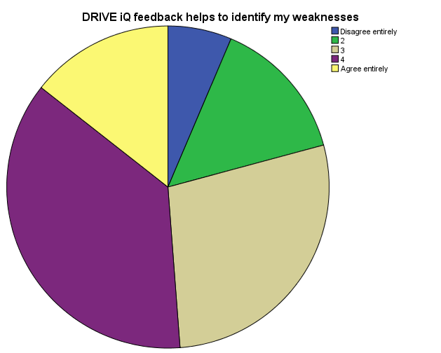

Figure 8.3: DRIVE iQ identifies weaknesses after Stage 1 Training

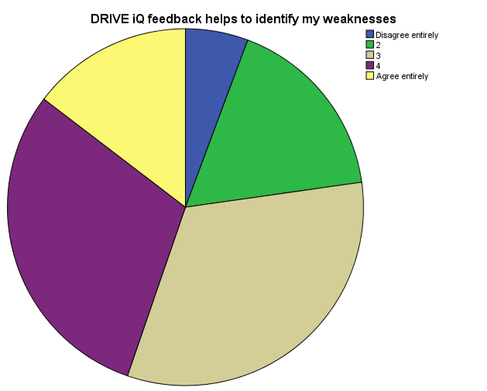

Figure 8.4: DRIVE iQ identifies weaknesses after Stage 2 Training

DRIVE iQ improves driving performance
After undergoing their Stage 1 driver training, Larkhill participants were asked whether DRIVE iQ modules helped to improve their performance in the vehicle. The majority of the participants (41%) agreed with this statement (see Figure 8.5) and this increases to 47% after Stage 2 (see Figure 8.6). This increase in level of agreement can be explained with reference to Stage 2 training allowing participants to put into practise the knowledge and skills acquired at Stage 1 via the DRIVE iQ platform.

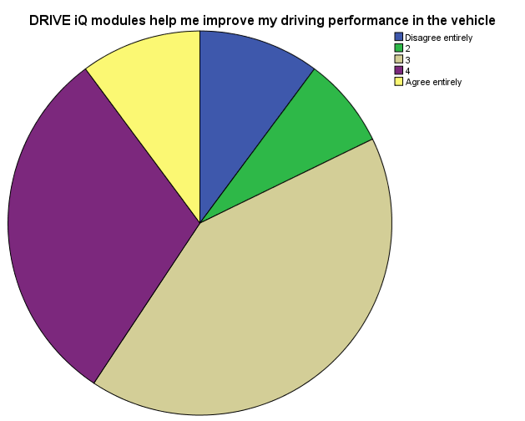

Figure 8.5: DRIVE iQ improves driving performance after Stage 1 Training

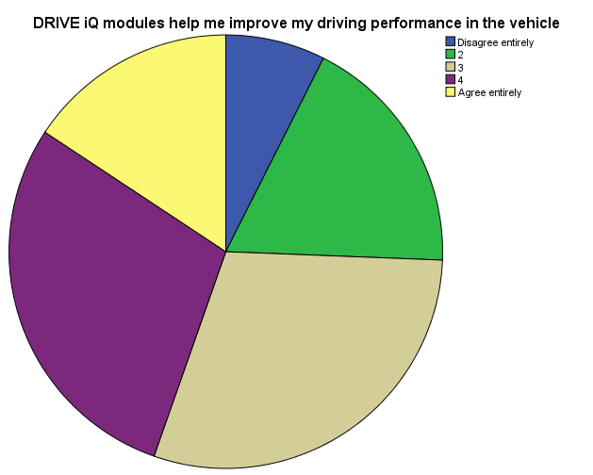

Figure 8.6: DRIVE iQ improves driving performance after Stage 2 Training

DRIVE iQ improves knowledge about hazards
After undergoing their Stage 1 driver training, Larkhill participants were asked whether DRIVE iQ modules helped to improve their knowledge about hazards. The overwhelming majority of the participants (69%) agreed with this statement (see Figure 8.7) and this reduces somewhat to 63% after Stage 2 (see Figure 8.8). Perhaps the slight reduction in the percentage agreeing with this statement could be due to respondents’ apportioning more knowledge of hazards to their in-car training at Stage 2.

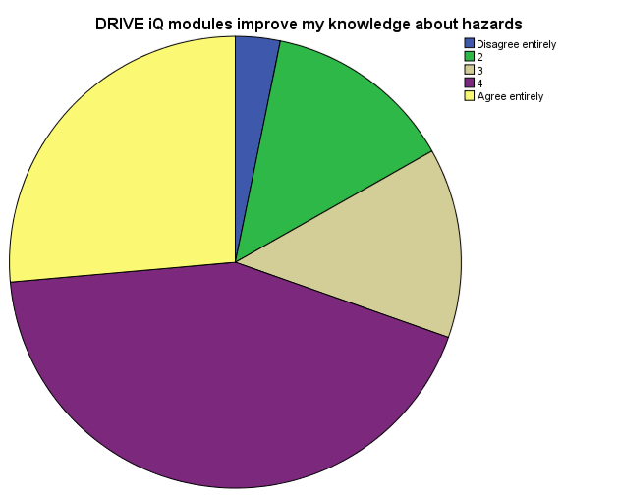

Figure 8.7: DRIVE iQ improves knowledge of hazards after Stage 1 Training

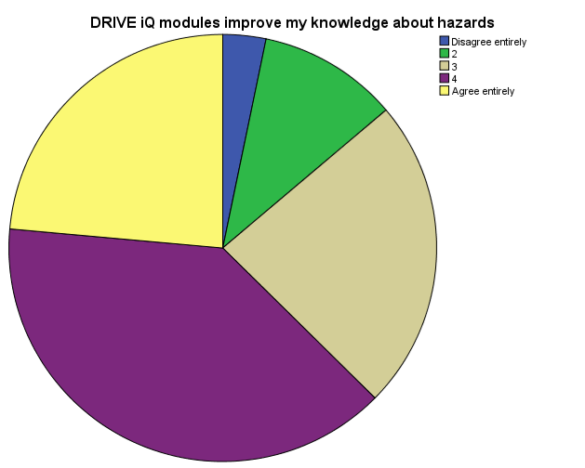
Figure 8.8: DRIVE iQ improves knowledge of hazards after Stage 2 Training

DRIVE iQ improves knowledge about the risks of driving
After undergoing their Stage 1 driver training, Larkhill participants were asked whether DRIVE iQ modules helped to improve their knowledge about the risks of driving. The overwhelming majority of the participants (64%) agreed with this statement (see Figure 8.9) which reduces somewhat to 56% after Stage 2 (see Figure 8.10). Perhaps the slight reduction in the percentage agreeing with this statement could be due to respondents’ apportioning more knowledge of the risks of driving to their in-car training as they progress through Stage 2 practical in-car training.

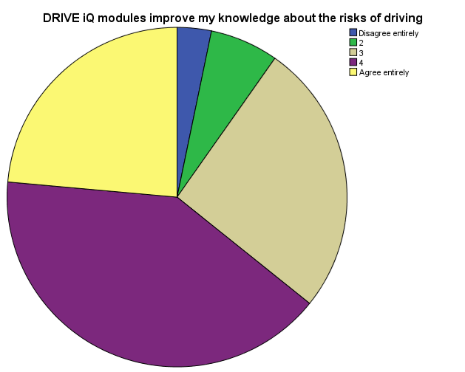

Figure 8.9: DRIVE iQ improves knowledge of driving risks after Stage 1 Training

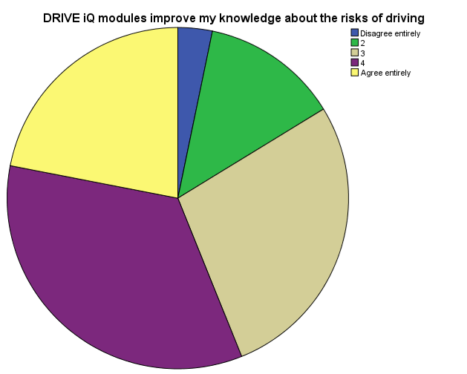

Figure 8.10: DRIVE iQ improves knowledge of driving risks after Stage 2 Training

DRIVE iQ not necessary for learning to drive
Statements phrased in the negative towards DRIVE iQ are important to ensure a fair balance. After undergoing their Stage 1 driver training, Larkhill participants were asked whether DRIVE iQ modules were not necessary for learning to drive. Half of the participants (49%) disagreed with this statement (see Figure 8.11) which decreases to 42% after Stage 2 (see Figure 8.12). Perhaps the slight reduction in the percentage disagreeing with this statement could be due to respondents’ apportioning more importance to their in-car training as they progress through Stage 2 practical training.

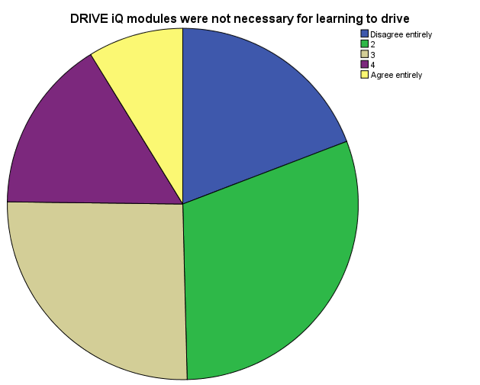

Figure 8.11: DRIVE iQ not necessary for learning to drive after Stage 1 Training

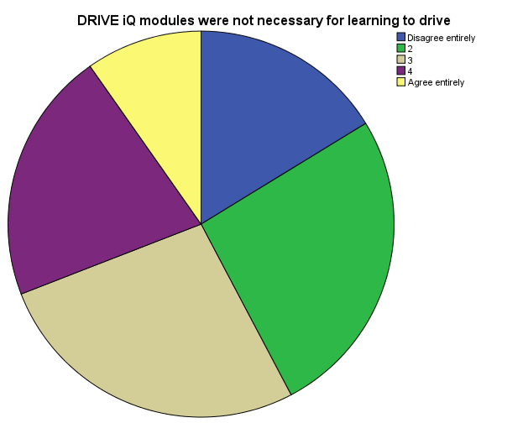

Figure 8.12: DRIVE iQ not necessary for learning to drive after Stage 2 Training

DRIVE iQ easy to use
After undergoing their Stage 1 driver training, Larkhill participants were asked whether DRIVE iQ modules were easy to use. The overwhelming majority of the participants (60%) agreed with this statement (see Figure 8.13) which increases to nearly 71% after Stage 2 (see Figure 13). Perhaps the increase in the numbers of participants agreeing that the modules were easy to use is due to increasing familiarity with the platform over time.

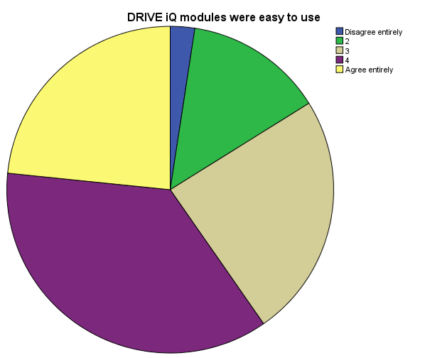

Figure 8.13: DRIVE iQ easy to use after Stage 1 Training

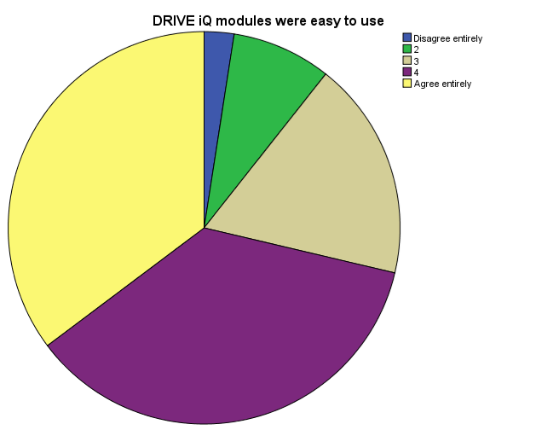

Figure 8.14: DRIVE iQ easy to use after Stage 2 Training

DRIVE iQ help in being a safer driver
After undergoing their Stage 1 driver training, Larkhill participants were asked whether the thought the DRIVE iQ modules helped them to become a safer driver. Most participants (55%) agreed with this statement (see Figure 8.15) and this proportion increases to 58% after Stage 2 (see Figure 8.16).

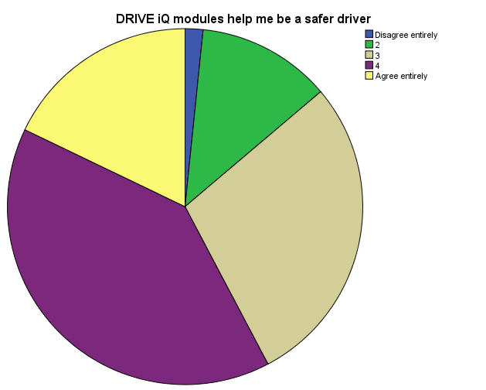Figure 8.15: DRIVE iQ helps in safer driving after Stage 1 Training

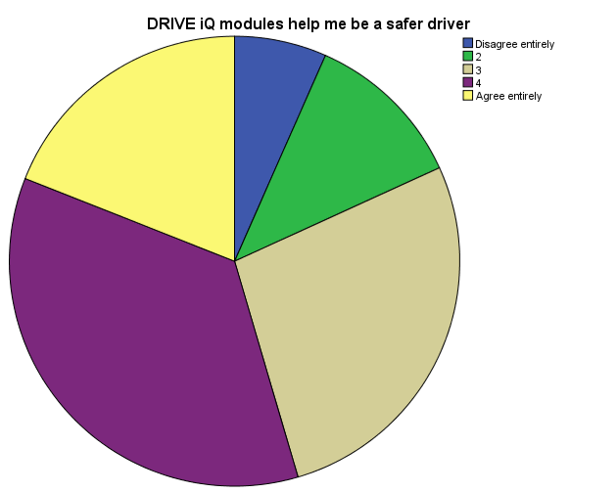

Figure 8.16: DRIVE iQ helps me in safer driving after Stage 2 Training

OBJECTIVE 2: Questionnaire Responses
Analysis was restricted to Questionnaires 1 and 2 only; that is pre- and post-theory training. The analysis is from data from Section B and questions 1 and 2 from Section C; that is, all those responses which are personal opinions regarding road risk. In this section, only significant results are described and/or illustrated
Overall, there was remarkable consistency between the groups from RSA, Larkhill and RSME, Minley. Therefore the null hypothesis—that there is no significant difference in the responses of the two groups—cannot be rejected in most cases. In 8 out of the 20 items there were no significant between-groups or within-group effects; in other words, the responses of both groups were similar before training and remained pretty much unchanged after training.
Twelve of the 20 items have significant within-group effects: in six items for both RSA, Larkhill and RSME, Minley; in three for RSA, Larkhill only; and in three for RSME, Minley only. In all but one of these cases, the within-group effect is an increase over time in the “perception of danger” rating (which is applicable to the first eight items in Section B) or in the “agreement” rating (which is applicable to the remaining 10 items in Section B). The exception is the item “Sometimes you have to drive in excess of the speed limit in order to keep up with the traffic flow,” for which both groups’ agreement reduced significantly over time. The biggest change for both groups pre- to post-training is for the following item:

How dangerous do you think the following action is while driving: talking to a passenger?
Main effect: risk rating increases from Q1 to Q2. No significant between-groups effect. Significant within-group effects for both groups:
Larkhill: Z = -4.376; p = .001; n = 125 Minley: Z = -5.372; p = .001; n = 77.
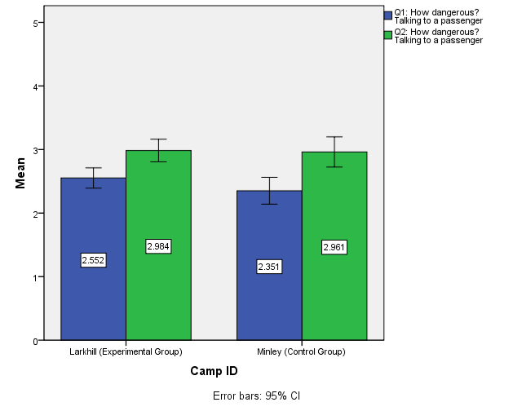
In only two cases was there a significant difference in the pre-training responses at Q1, and so for these items the null hypothesis can be rejected. For the items “How dangerous do you think the following action is while driving: keep driving even though you are very tired?” and “How dangerous do you think the following action is while driving: change lanes without checking properly for vehicles in other lanes?” the RSA, Larkhill group gave higher initial scores. However, in both those cases, the RSME, Minley group increased its ratings at Q2 so that they then matched RSA, Larkhill’s. In all other cases the pre-training scores were not significantly different.

How dangerous do you think the following action is while driving: keep driving even though you are very tired?
Main effect: risk rating increases from Q1 to Q2. Significant between-groups effect for Q1 (Z = -2.386; p = .017; n = 220). Significant within-group effects for both groups: Larkhill: Z = -2.041; p = .041; n = 125; Minley: Z = -3.801; p = .001; n = 77.
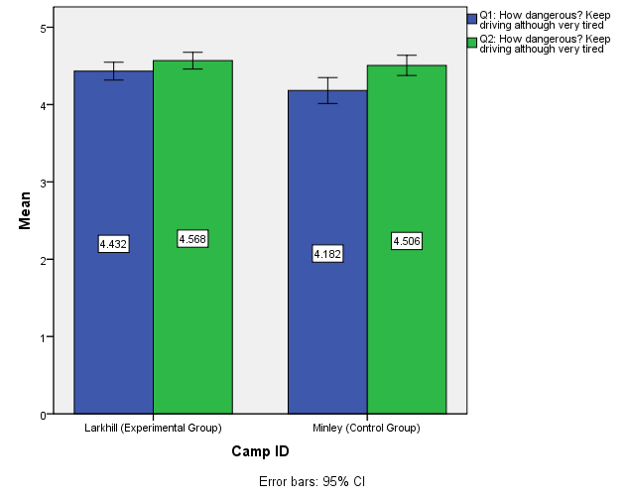

How dangerous do you think the following action is while driving: change lanes without checking properly for vehicles in other lanes?
Significant between-groups effect for Q1 (Z = -2.711; p = .007; n = 220). Significant within-group effect for Minley: risk rating increases from Q1 to Q2 (Z = -2.776; p = .006; n = 77).

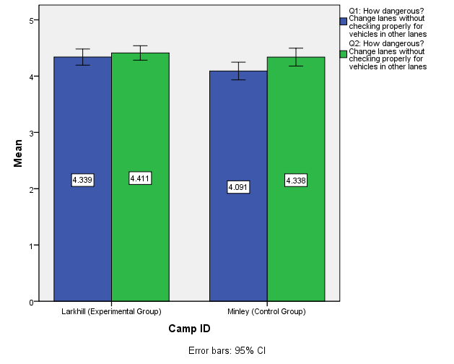
In only three cases was there a significant difference in the post-training responses at Q2 and so for these, too, the null hypothesis can be rejected. For the item “How dangerous do you think the following action is while driving: turn right across a busy road even when there is a small chance of a collision?” the RSA, Larkhill group significantly increased its “danger rating” from Q1 to Q2 while the RSME, Minley scores showed no significant difference.

How dangerous do you think the following action is while driving: turn right across a busy road even when there is a small chance of a collision?
Significant between-groups effect for Q2 (Z = -2.333; p = .020; n = 202). Significant within-group effect for Larkhill (Z = -3.431; p = .001; n = 124).
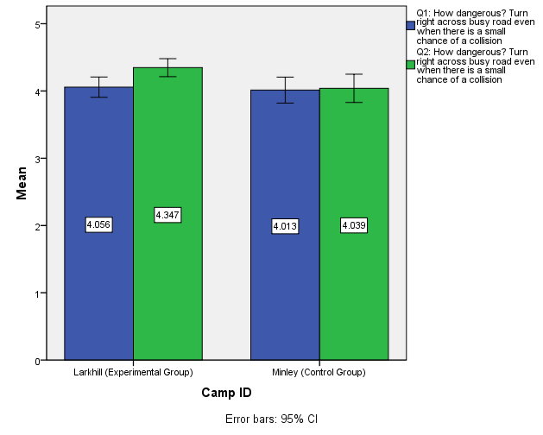
A similar effect (but reversed) is seen in the item “I would favour stricter enforcement of speed limits on road”: the RSME, Minley scores have no significant difference from Q1 to Q2 while the RSA, Larkhill scores have a significant decrease in the “agreement rating” from Q1 to Q2.

I would favour stricter enforcement of speed limits on roads
Significant between-groups effect for Q2 (Z = -2.356; p = .018; n = 202). Significant within-group effect for Larkhill: agreement rating decreases from Q1 to Q2 (Z = -2.927; p = .003; n = 125)
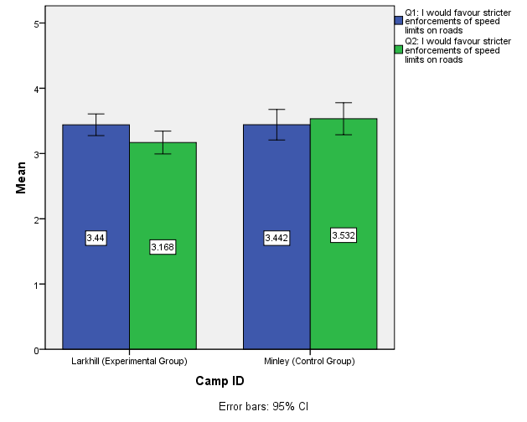
The item “I would be happier if speed limits were more strictly enforced” shows by far the largest between-groups effect: post-training, the RSA, Larkhill participants became less happy with this idea while the RSME, Minley participants became happier (both were significant within-group effects). This is the only item in which there were significant pre- to post-training changes in opposite directions.

I would be happier if speed limits were more strictly enforced
Significant between-groups effect for Q2 (Z = -4.228; p = .001; n = 182). Significant within-group effects for both groups: Larkhill: risk rating decreases from Q1 to Q2 (Z = -2.775; p = .006; n = 105); Minley: risk rating increases from Q1 to Q2 (Z = -3.136; p = .002; n = 77).
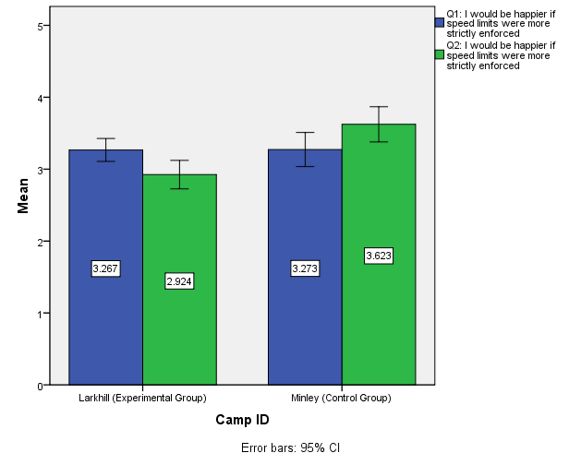
Although, for the two items in Section C, questions only one significant (and quite small) within-group effect is found, they are presented here because the difference in the anticipation of risk to, respectively, self and others is discussed in the next section.
[In the next 2 items, on the Y axis 1 = 20%, 2 = 40%, 3 = 60%, 4 = 80% and 5 = 100%.]

What is the likelihood of YOU being involved in a crash within the first few months of passing your driving test?
No significant between-groups effects. Significant within-group effect for Larkhill: risk rating increases from Q1 to Q2 (Z = -2.453; p = .014; n = 123).
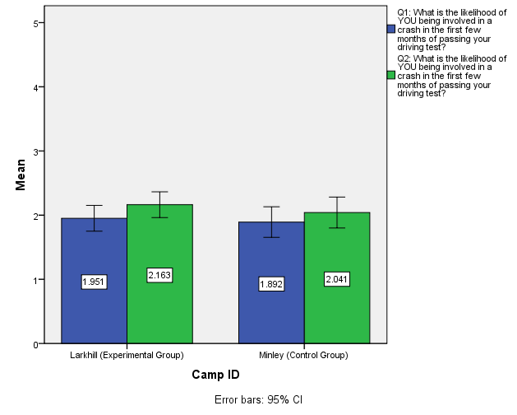

What is the likelihood of SOMEONE OF YOUR AGE AND SEX being involved in a crash within the first few months of passing your driving test?
No significant between-groups or within-group effects.
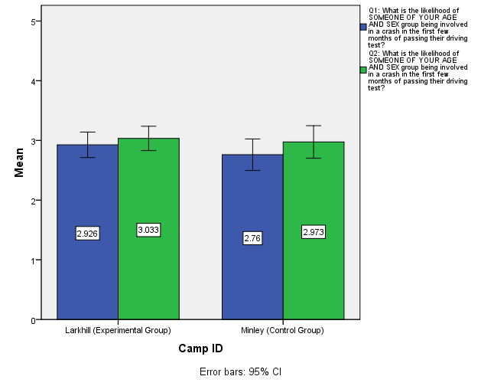

8 Driving Test Results
The hypothesis being tested is: that exposure of the experimental group to the DRIVE iQ e-learning will improve pass rates for the practical driving test components compared with the pass rates for the control group.
The experimental group achieved a higher pass rates for the practical driving test compared with the pass rates for the control group. As can be seen from Table 8.1, 34 driving test results were missing from the sample of 92 Minley participants but only 1 missing out of 128 for the experimental group, RSA, Larkhill. Setting aside the problem of missing data for the moment, if the Cumulative Percent column is checked for the row “Passed third test,” it will be seen that 91.3% at RSA, Larkhill (the experimental group) but only 72.4% at RSME, Minley (the control group) of the participants whose results are known had passed the driving test by the third attempt. These percentages are the significant cut-off point because the Army regards its driver training as having been successful if trainees pass the driving test within 3 attempts. Any other outcomes are regarded as “wastage” of training (the reduction of which is one of the objectives for the present study). On that basis alone, the driving test performance of the experimental group is significantly superior to that of the control group.

Table 8.1 SPSS Frequencies Output for Driving Test Results
Driving Tests to Pass
Camp ID |  |  |  | Frequency | Percent | Valid Percent | Cumulative Percent
Larkhill (Experimental Group) | Valid |  | Passed first test | 66 | 51.6 | 52.0 | 52.0
Larkhill (Experimental Group) |  |  | Passed second test | 29 | 22.7 | 22.8 | 74.8
Larkhill (Experimental Group) |  |  | Passed third test | 21 | 16.4 | 16.5 | 91.3
Larkhill (Experimental Group) |  |  | Passed fourth test | 7 | 5.5 | 5.5 | 96.9
Larkhill (Experimental Group) |  |  | Passed fifth test | 1 | .8 | .8 | 97.6
Larkhill (Experimental Group) |  |  | Withdrawn from practical training; no tests | 3 | 2.3 | 2.4 | 100.0
Larkhill (Experimental Group) |  |  | Total | 127 | 99.2 | 100.0
Larkhill (Experimental Group) | Missing |  | 99 | 1 | .8
Larkhill (Experimental Group) | Total |  |  | 128 | 100.0
Minley (Control Group) | Valid | Passed first test |  | 28 | 30.4 | 48.3 | 48.3
Minley (Control Group) | Valid | Passed second test |  | 10 | 10.9 | 17.2 | 65.5
Minley (Control Group) | Valid | Passed third test |  | 4 | 4.3 | 6.9 | 72.4
Minley (Control Group) | Valid | Theory course only; no practical training |  | 10 | 10.9 | 17.2 | 89.7
Minley (Control Group) | Valid | Withdrawn from practical training; no tests |  | 2 | 2.2 | 3.4 | 93.1
Minley (Control Group) | Valid | First course failed three tests; second course passed first (fourth) test |  | 1 | 1.1 | 1.7 | 94.8
Minley (Control Group) | Valid | Withdrawn from first course; second course passed first test |  | 2 | 2.2 | 3.4 | 98.3
Minley (Control Group) | Valid | Withdrawn from first course; second course passed second test |  | 1 | 1.1 | 1.7 | 100.0
Minley (Control Group) | Valid | Total |  | 58 | 63.0 | 100.0
Minley (Control Group) | Missing | 99 |  | 34 | 37.0
Minley (Control Group) | Total |  |  | 92 | 100.0

However, it is useful to consider what the best- and worst-case scenarios would be if all results were known, and to see how these would affect the comparison of results from the two groups. For RSA, Larkhill the best-case scenario is that the single missing result is a driving test pass within three attempts, the worst-case scenario is no pass within three attempts. If the former, the RSA, Larkhill pass rate within three attempts for the 128 participants would be 91.4%, and if the latter, it would be 90.6%. For RSME, Minley the best-case scenario is that all the 34 missing results were passes within three attempts. If that were so, the control group would have a training “success” rate of 82.6%, which is still well below the minimum of 90.6% that would be achieved by the experimental group. The worst-case scenario is that none of the 34 missing results were passes within three attempts. If that were so, the control group would have a training “success” rate of only 45.6%: that is, just half that of the experimental group. It may be noted that only six of the 34 participants with missing test results had returned all three questionnaires; therefore it is possible that the other 28 did not complete their training.
As explained in the previous section, in order to make use of the driving test data available, an analysis was performed to see whether there was a relationship between previous driving experience and passing the practical driving test within three attempts. Using two new variables that were recoded from variables in the original dataset and named “Previous experience” and “Pass first 3 tests,” a cross-tabulation was carried out, with the dataset split by Camp ID. The SPSS output tables for the cross-tabulation may be found at the end of Appendix F. It may be seen by inspecting the output tables that previous experience seemed to have absolutely no effect within the experimental group. Some effect may be seen in the control group: those with previous experience were more likely than expected (from their proportion in the sample) to have passed within three tests, and those without experience were less likely than expected to have passed within three tests, but the result was not statistically significant (p > .05) (see Appendix C).

DISCUSSION of results
The primary aim of this study was to determine whether the supplementation of Army basic driver training with the DRIVE iQ e-learning system would produce benefits such as improvements in drivers’ performance, reduction of drivers’ exposure to risk and reduction of “wastage” in Army driver training. In this section: the limitations of the study will be examined; the significance of the results that have been obtained will be discussed; and the methodology of the study itself.
The DRIVE iQ feedback provides an immediate subjective personal opinion regarding the efficacy of the product rather than an objective independent measurement of related performance. It is important that the MoD are aware that the DRIVE iQ product was generally well received by its target users. In view of the nature of the study, the most significant of all the responses were those in regard to items D4: DRIVE iQ modules improve my knowledge about hazards, and D5: DRIVE iQ modules improve my knowledge about the risks of driving. In both cases, agreement with the statement was much greater than disagreement.
The questionnaires that were completed by both groups showed little in the way of differences; the within-groups differences tended to be quite small even when they were statistically significant, and there were fewer statistically significant between-groups differences. The most commonly observed differences were small increases in rating from pre-Stage 1 to post-Stage1 training. It would appear that the DRIVE iQ modules had little effect on how the participants completed the questionnaires. Of course, the questionnaires could not measure actual hazard awareness but only participants’ opinions about hazards and risk, neither did they give any indication of the participants’ actual driving ability: the driving test data was more useful in that regard. These findings with regard to the questionnaires confirm the findings of Farrand and McKenna (2001), who found no correlation between young drivers’ ratings of risk on questionnaires and their performance on hazard perception tests. While the data are not there to confirm it, there is a suspicion that many of the missing test results from the control group may have been related to the participants’ failure of the theory (and hazard perception) test, yet that group’s questionnaire responses were quite similar to the experimental group who clearly had a very high theory (and hazard perception) test pass rate.
Two items in the questionnaires (Section C, items 1 and 2) confirm Finn and Bragg’s (1986) findings: the estimation of young drivers’ own risk of crashing was significantly lower than their estimation of the risk of crashing by others of the same age and gender; this differential was consistent across the first and second questionnaires and between the groups.
The main limitation in the study was the absence of some data, mostly from the control group at RSME, Minley. The very small sample of Questionnaire 3s that were returned prevented a three-stage repeated measure from being carried out.

RECOMMENDATIONS
- Massed driving practice with an intense period of 2-3 weeks to acquire a driving licence is disadvantageous to safety for the MoD. If this approach is to continue due to resource demands, then this study suggests that a higher level of understanding of driving risks should be included in the curriculum and implemented throughout the training period, starting with the very youngest, 16 years-old, recruits. While they would not be able to drive on the public road at that age, they could have access to e-learning, take part in discussions that focus on the higher levels of the Goals for Driver Education.
- Older recruits could benefit from a similar approach: it is not necessary to be enrolled in the driving school in order to use driver educational e-learning and to take part in GDE-style discussions. This resource can be easily available to all the armed forces to reduce risk.
- Given the potential of the contribution that could be made by enhanced training methods such as the DRIVE iQ e-learning, a large-scale trial is proposed.
- Objective data to assess driving performance and safety should be used rather than questionnaires. a2om’s eye scanning task could be administered to assess whether an improvement in hazard awareness had been achieved post-training.

CONCLUSION
It is essential, that the Army does all it can to ensure that the driving behaviour of its young soldiers is considerably less risky than that of most young, and especially young male, drivers. This study suggests that e-training may be a step in the right direction towards providing a more comprehensive driver education for young recruits.

References
Braver, E. R. (2003). Race, Hispanic origin, and socioeconomic status in relation to motor vehicle occupant death rates and risk factors among adults. Accident Analysis and Prevention, 35, p. 295–309
British Army (2011). Role Finder: Infantry Driver (web page), available at: http://www.army.mod.uk/rolefinder/role/79/infantry-driver (accessed 22 August, 2011).
Burdick, M. (2010). When biking’s in your blood. Army Safety & Environmental Matters, 39, p. 4‒6.
Carstensen, G. (2002). The effect on accident risk of a change in driver education in Denmark. Accident Analysis & Prevention, 34 (1), p. 111‒121. Cited in: OECD/ECMT Transport Research Centre. (2006). Young Drivers: The Road to Safety. OECD Publishing, Paris.
Clarke, D. D., Ward, P. and Truman, W. (2002). In-depth Accident Causation Study of Young Drivers. TRL Report 542. Transport Research Laboratory, Crowthorne.
Clarke, D. D., Ward P. and Truman W. (2005). Voluntary risk taking and skill deficits in young driver accidents in the UK. Accident Analysis and Prevention, 37, p. 523–529.
Clarke, D. D., Ward, P., Truman, W. and Bartle, C. (2007). Fatal vehicle-occupant collisions: an in-depth study. Road Safety Research Report 75, Department for Transport. DfT Publications, London.
Clarke D. D., Ward P., Bartle C. and Truman W. (2010). Killer crashes: Fatal road traffic accidents in the UK. Accident Analysis and Prevention, 42, p. 764–770.
Chowdhury, K. and Kilbey, P. (2010). General overview and trends in reported road casualties. In Reported Road Casualties Great Britain: 2009, Department for Transport. The Stationery Office, London, p. 8‒30.
Cooper, P. J., Pinili, M. and Chen, W. (1995). An examination of the crash involvement rates of novice drivers aged 16 to 55. Accident Analysis & Prevention, 27 (1), p. 89‒104. Cited in: OECD/ECMT Transport Research Centre. (2006). Young Drivers: The Road to Safety. OECD Publishing, Paris.
Dahl, R. E. and Spear, L. P. (2004). Adolescent brain development. Annals of the New York Academy of Sciences, 1021, p. 1–22.
Deery, A. H. (1999). Hazard and risk perception among young novice drivers. Journal of Safety Research, 30 (4), p. 225‒236.
Defence Analytical Services and Advice (2011). Deaths in the UK Regular Armed Forces 2010, Statistical Notice. Office for National Statistics, Newport.
Department for Transport (2011). Driver licence holding and vehicle availability. National Travel Survey 2010, available at http://assets.dft.gov.uk/statistics/releases/national-travel-survey-2010/nts2010-02.pdf (accessed 20 August, 2011).
Doidge, N. (2007). The Brain That Changes Itself. Penguin Books, London.
Driving Standards Agency (2011). Planning and recording how you learn to drive (web page), available at http://www.direct.gov.uk/en/motoring/learnerandnewdrivers/practicaltest/dg_4022483 (accessed 22 August, 2011).
Endsley, M. R. (1988). Design and evaluation for situation awareness enhancement. In Proceedings of the Human Factors Society 32nd Annual Meeting, p. 97‒101. Human factors Society, Santa Monica.
Evans, L. (2004). Traffic Safety. Science Serving Society, Bloomfield, Michigan.
Farrand, P. and McKenna, F. (2001). Risk perception in novice drivers: the relationship between questionnaire measures and response latency. Transportation Research Part F, 4, 201‒212.
Fear, N. T., Iversen, A. C., Chatterjee, A., Jones, M., Greenberg, N., Hull, L., Rona, R. J., Hotopf, M. and Wessely, S. (2008). Risky driving among Regular Armed Forces personnel from the United Kingdom. American Journal of Preventive Medicine, 35, (3), p. 230–236.
Finn, P. and Bragg, B. W. E. (1986). Perception of the risk of an accident by young and older drivers. Accident Analysis and Prevention, 18, p. 289–298.
Forsyth, E., Maycock, G. and Sexton, B. F. (1995). Cohort Study of Learner and Novice Drivers, Part 3: Accidents, Offences and Driving Experience in the First Three Years of Driving. Project Report PR 111. Transport Research Laboratory, Crowthorne. Cited in: OECD/ECMT Transport Research Centre. (2006). Young Drivers: The Road to Safety. OECD Publishing, Paris.
Gregersen, N. P., Berg, H.-Y., Engström, I., Nolén, S., Nyberg, A. and Rimmö, P.-A. (2000). Sixteen years age limit for learner drivers in Sweden—an evaluation of safety effects. Accident Analysis and Prevention, 32 (1), p. 25‒35.
Groeger, J. A. (2000). Understanding Driving: Applying cognitive psychology to a complex everyday task. Psychology Press, Hove.
Hatakka, M., Keskinen, E., Gregersen, N. P., Glad, A. and Hernetkoski, K. (2002). From control of the vehicle to personal self-control; broadening the perspectives to driver education. Transportation Research Part F, 5, p. 201–215.
Hopkin, J. (2008). Young drivers—where and when are they unsafe: analysis of road accidents in Great Britain 2000–2006. IAM Motoring Trust, London.
Howard, E. (2004). Victoria’s experience and young driver safety issues. Presentation to the Young Driver Safety Forum, Canberra, December 2004. VicRoads, Melbourne. Cited in: OECD/ECMT Transport Research Centre. (2006). Young Drivers: The Road to Safety. OECD Publishing, Paris.
Hull, C. L. (1943). Principles of Behaviour. Appleton Century Crofts, New York. Cited in: Groeger, J. A. (2000). Understanding Driving: Applying cognitive psychology to a complex everyday task. Psychology Press, Hove.
Isler, R. B., Starkey, N. J. and Drew, M. (2008). The “Frontal Lobe” Project: A double-blind, randomized controlled study of the effectiveness of higher level driving skills training to improve frontal lobe (executive) function related driving performance in young drivers, Final Report. University of Waikato, Hamilton, New Zealand.
Isler, R. B., Starkey, N. J. and Williamson, A. R. (2009). Video-based road commentary training improves hazard perception of young drivers in a dual task. Accident Analysis and Prevention, 41, p. 445–452.
Janis, I. L. and Mann, L. (1977). Decision Making. Free Press, New York.
Klauer, S. G., Dingus, T. A., Neale, V. L., Sudweeks, J. and Ramsey, D. (2006). The Impact of Driver Inattention on Near-Crash/Crash Risk: An Analysis Using the 100-Car Naturalistic Driving Study Data. Report No. DOT HS 810 594. National Highway Traffic Safety Administration, Washington, DC.
Maycock, G., Lockwood, C. and Lester, J. (1991). The Accident Liability of Car Drivers. TRL Research Report 315. Transport Research Laboratory, Crowthorne. Cited in: OECD/ECMT Transport Research Centre. (2006). Young Drivers: The Road to Safety. OECD Publishing, Paris.
Maycock, G. (2002a). Novice Driver Accidents and the Driving Test. TRL Research Report 527. Transport Research Laboratory, Crowthorne, UK. Cited in: OECD/ECMT Transport Research Centre. (2006). Young Drivers: The Road to Safety. OECD Publishing, Paris.
Maycock G. (2002b). Estimating the effects of age and experience on accident liability using Stats19 data. In Behavioural Research in Road Safety XII. Department for Transport, London. Cited in: OECD/ECMT Transport Research Centre. (2006). Young Drivers: The Road to Safety. OECD Publishing, Paris.
Mayhew, D. R., Simpson, H. M. and Pak, A. (2000). Changes in Collision Rates Among Novice Drivers During the First Months of Driving. Insurance Institute for Highway Safety, Arlington. Cited in: OECD/ECMT Transport Research Centre. (2006). Young Drivers: The Road to Safety. OECD Publishing, Paris.
Mayhew, D. R., Simpson, H. M. and Pak, A. (2003). Changes in collision rates among novice drivers during the first months of driving. Accident Analysis and Prevention, 35, p. 683–691.
McKenna, F. (2010). Education in Road Safety: Are we getting it right? Report Number 10/113. The Royal Automobile Club Foundation for Motoring, London.
McKnight, A. J. and McKnight, A. S. (2003). Young novice drivers: careless or clueless? Accident Analysis & Prevention, 35, p. 921‒925.
Moe, D. and Jensen, G. D. (1990). Unge førere, risikotaking og pedagogiske konsekvenser. SINTEF Report STF63 A90007, SINTEF Samferdselsteknikk, Trondheim. Cited in: OECD/ECMT Transport Research Centre. (2006). Young Drivers: The Road to Safety. OECD Publishing, Paris.
OECD/ECMT Transport Research Centre. (2006). Young Drivers: The Road to Safety. OECD Publishing, Paris.
Ohberg, A., Penttila, A. and Lonnqvist, J. (1997). Driver suicides. British
Rasmussen, J. (1984). Information Processing and Human-Machine Interaction: An Approach to Cognitive Engineering. North-Holland, New York. Cited in: Gregersen, N. P., Berg, H.-Y., Engström, I., Nolén, S., Nyberg, A. and Rimmö, P.-A. (2000). Sixteen years age limit for learner drivers in Sweden—an evaluation of safety effects. Accident Analysis and Prevention, 32 (1), p. 25‒35.
Reason, J. (1990). Human Error. Cambridge University Press, Cambridge.
Ryan G. A., Legge, M. and Rosman, D. (1998). Age related changes in drivers’ crash risk and crash type. Accident Analysis & Prevention, 30 (3), p. 379‒387.
Sagberg, F. (2000). Evaluation of the 16-years Age Limit for Practicing with Private Car: Accident Risk After the Driver’s Test (in Norwegian). TØI report 498. Transportøkonomisk Institutt (TØI), Oslo. Cited in: OECD/ECMT Transport Research Centre. (2006). Young Drivers: The Road to Safety. OECD Publishing, Paris.
Schade, F.-D. (2001). Daten zur Verkehrsbewährung von Fahranfängern, Reanalyse von Rohdaten der Untersuchung: Hansjosten, E. & Schade, F.-D. (1997). Legalbewährung von Fahranfängern: Berichte der Bundesanstalt für Straßenwesen, Heft M 71. Unpublished manuscript, Kraftfahrt-Bundesamt (KBA), Flensburg, Germany. Cited in: OECD/ECMT Transport Research Centre. (2006). Young Drivers: The Road to Safety. OECD Publishing, Paris.
Vlakveld, W. P. (2004). New policy proposals for novice drivers in the Netherlands. In Behavioural Research in Road Safety 2004, Fourteenth Seminar. Department for Transport, London. Cited in: OECD/ECMT Transport Research Centre. (2006). Young Drivers: The Road to Safety. OECD Publishing, Paris.
VicRoads (State of Victoria, Australia), (2005). Young Driver Safety and Graduated Licensing Discussion Paper. Have Your Say! State of Victoria, Melbourne. Cited in: OECD/ECMT Transport Research Centre. (2006). Young Drivers: The Road to Safety. OECD Publishing, Paris.
af Wåhlberg, A. E. (2010). Re-education of young driving offenders; Effects on self-reports of driver behaviour. Journal of Safety Research, 41, p. 331–338.
Ward, H., Shepherd, N., Robertson, S., Thomas, M. (2005). Night-time accidents: a scoping study. Report to the AA Motoring Trust and Rees Jeffreys Road Fund. The AA Motoring Trust, London.
Ward, N. J. and Okpala, E. (2005). Analysis of 47 road traffic accident admissions to BMH Shaibah. Journal of the Royal Army Medical Corps, 151, p. 37‒40.
Wells, P., Tong, S., Sexton, B., Grayson, G. and Jones, E. (2008). Cohort II: A Study of Learner and New Drivers Volume 1—Main Report. Road Safety Research Report No. 81, Department for Transport, London.
Williams, A. F. (1996). Magnitude and characteristics of the young driver crash problem in the United States. In: New to the Road: Reducing the Risks for Young Motorists, edited by H. Simpson. Youth Enhancement Service, UCLA School of Medicine, Los Angeles. p. 19–25. Cited in: McKnight, A. J. and McKnight, A. S. (2003). Young novice drivers: careless or clueless? Accident Analysis & Prevention, 35, p. 921‒925.
Williams, A. F., Preusser, D. F., Ferguson, S. A. and Ulmer, R. G. (1997). Analysis of the fatal crash involvements of 15-year-old drivers. Journal of Safety Research, 28 (1), p. 49–54. Cited in: Mayhew, D. R., Simpson, H. M. and Pak, A. (2003). Changes in collision rates among novice drivers during the first months of driving. Accident Analysis and Prevention, 35, p. 683–691.
Wilson, R. J. and Jonah, B. (1988). The application of problem-behaviour theory to the understanding of risky driving. Alcohol, Drugs and Driving, 4, p. 173‒191. Cited in: OECD/ECMT Transport Research Centre. (2006). Young Drivers: The Road to Safety. OECD Publishing, Paris.
Yu, J. and Williford, W. R. (1993). Alcohol and risk/sensation seeking: Specifying a causal model of high-risk driving. Journal of Addictive Diseases, 12, p. 79‒96. Cited in: OECD/ECMT Transport Research Centre. (2006). Young Drivers: The Road to Safety. OECD Publishing, Paris.

Appendix A Demographics of Participants
Larkhill (Experimental Group)  n = 128 | Minley (Control Group)  n = 92
Gender
113 male, 15 female: 88.3% male | 91 male, 1 female: 98.9% male
Age
Age range: 17‒31  Mean of ages: 19.82 (SD = 3.203) | Age range: 17‒33  Mean of ages: 20.02 (SD = 3.524)
Previous experience of driving/riding motorised vehicles
Any vehicle (n = 127): 66.93% (85)  Car driving experience (n = 127): 52.76% (67)  Car only; no PTW (n = 127): 25.20% (32)  PTW riding experience (n = 128): 41.41% (53)  PTW only; no car (n = 127): 14.17% (18)  Both car and PTW (n = 127): 27.56% (35)  No previous experience (n = 127): 33.07% (42) | Any vehicle (n = 92): 57.61% (53)  Car driving experience (n = 92): 44.57% (41)  Car only; no PTW (n = 92): 13.04% (12)  PTW riding experience (n = 92): 45.65% (42)  PTW only; no car (n = 92): 15.22% (14)  Both car and PTW (n = 92): 30.43% (28)  No previous experience (n = 92): 42.39% (39)
[Percentages of subset of female participants only: n = 15]  Any vehicle 33.33% (5)  Car only 26.67% (4)  PTW only 0% (0)  Both car and PTW 6.67% (1)  No previous experience: 66.67% (10) | [Percentages of subset of female participants only: n = 1]  No previous experience: 100% (1)

Previous driver training and practice
[Percentages of subset with car driving experience: n = 67 (52.76% of whole group)]  Professional instruction only:  20.90% (14)  Private practice only: 43.28% (29)  Both professional instruction and private practice: 35.82% (24)  [Percentages of subset with professional driving instruction: n = 38]  0‒4 hours: 7.89% (3)  5‒9 hours: 23.68% (9)  10‒14 hours: 23.68% (9)  15+ hours: 44.74% (17)  [Percentages of subset with private practice: n = 52]  0‒4 hours: 55.77% (29)  5‒9 hours: 15.38% (8)  10‒14 hours: 9.62% (5)  15+ hours: 19.23% (10) | [Percentages of subset with car driving experience: n = 41 (44.57% of whole group)]  Professional instruction only:  7.32% (3)  Private practice only: 48.78% (20)  Both professional instruction and private practice: 41.46% (17)  [Percentages of subset with professional driving instruction: n = 20]  0‒4 hours: 25.00% (5)  5‒9 hours: 30.00% (6)  10‒14 hours: 25.00% (5)  15+ hours: 20.00% (4)  [Percentages of subset with private practice: n = 37]  0‒4 hours: 64.86% (24)  5‒9 hours: 10.81% (4)  10‒14 hours: 2.70% (1)  15+ hours: 21.62% (8)
Motorcycle training and licensing
[Percentages of subset with PTW riding experience: n = 53 (41.41% of whole group)]  Motorcycle training taken: 33.96% (18)  Motorcycle licence held: 28.30% (15) | [Percentages of subset with PTW riding experience: n = 42 (45.65% of whole group)]  Motorcycle training taken: 23.81% (10)  Motorcycle licence held: 14.29% (6)

Summary of demographics
The experimental group is approximately 40% larger than the control group. Both groups are predominantly male, but especially so in the control group. The means, distributions and ranges of ages in both groups are very similar.
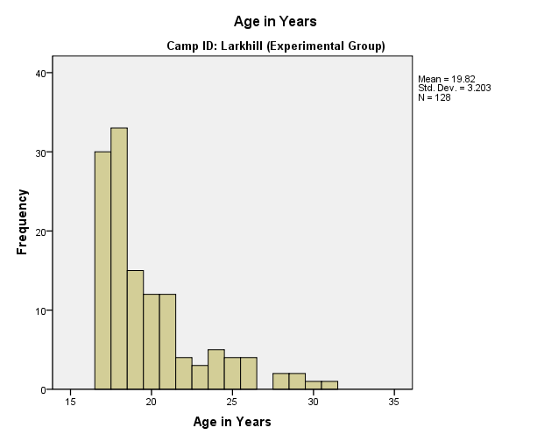
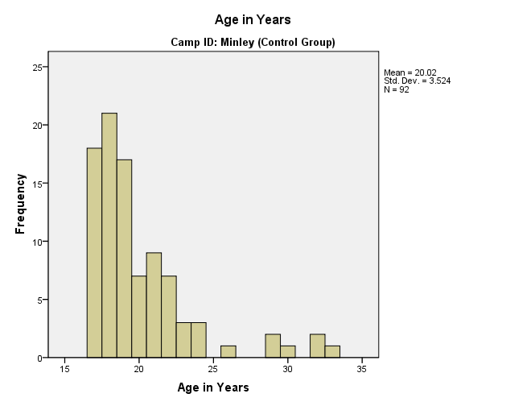
A higher percentage of the experimental group has previous driving/riding experience than the control group. However, this is concentrated in car driving experience; a larger portion of the control group has PTW riding experience. Amongst experienced participants, the amount of previous experience (hours of instruction and hours of practice) is higher in the experimental group than the control group.
The female participants have less previous experience than the male participants. Across both groups, 68.75% of female participants have no previous driving/riding experience but only 33.70% of male participants have no previous driving/riding experience. Amongst participants with previous experience, those in the experimental group were more likely to have had professional training and more of it; the control group was more inclined towards “DIY.” This is particularly noticeable amongst those with PTW experience: Larkhill participants were twice as likely as Minley participants to have obtained a motorcycle licence.

Appendix B Questionnaire Items

Instructions
[The same wording appears on all questionnaires] Cranfield University is conducting a study on what new recruits think about driving. The information you provide is entirely confidential. Your responses to this questionnaire will be anonymous and no information you provide will go back to your chain of command or your instructors.
Your views about driving are important to us. Please answer the following questions honestly.

Section A
First questionnaire to all participants:
1. Your service number:
2. Your age:
3. Date of birth:
4. Your gender Male Female
[In questionnaires 2 and 3, Section A is abbreviated to the above 4 items.]
5. Have you ever ridden a powered two-wheeler? Yes No
6. If yes, do you have a powered two-wheeler licence? Yes No
7. Have you ever received professional lessons to ride a powered two-wheeler?
Yes No
8. What date did you obtain your provisional driving licence? Give an approximate date if you can’t remember:
9. Have you ever received any professional driving instruction before joining the forces? Yes No
10.If yes, approximately how many hours of driving tuition have you received from a professional driving instructor in total? 0‒4 hrs 5‒9 hrs 10‒14 hrs 15 hrs +
11. Have you ever driven a car with guidance from family and friends? Yes No
12. If yes, approximately how many hours of driving tuition have you received from friends and family in total? 0‒4 hrs 5‒9 hrs 10‒14 hrs 15 hrs +
13. Approximately how many miles of driving practice have you had IN TOTAL outside your service training (with friends and family)?
0‒99 100‒199 200‒299 300‒399 400‒499 500 +
[For the experimental group (RSA, Larkhill) only, Questionnaires 2 and 3 had the following 8 items included in Section A. All responses were made on a 5-point Likert scale from 1 = Disagree entirely to 5 = Agree entirely.]
Please indicate how much you agree with the following statements by MARKING a number from 1 to 5. MARK one number for each of the following statements.
D1. I enjoyed the DRIVE iQ on-line modules.
D2. DRIVE iQ feedback helps me to identify my weaknesses.
D3. DRIVE iQ modules help me improve my driving performance in the vehicle.
D4. DRIVE iQ modules improve my knowledge about hazards.
D5. DRIVE iQ modules improve my knowledge about the risks of driving.
D6. DRIVE iQ modules are not necessary for learning to drive.
D7. DRIVE iQ modules were easy to use.
D8. DRIVE iQ modules help me to be a safer driver.

Section B
[Same in all questionnaires] This section asks you to answer some questions relating to what you think about driving. Please answer the questions accurately and honestly. Your first reactions are usually the best ones.
These questions ask you to consider HOW DANGEROUS you think certain actions are while driving. MARK the number that best represents how you think about the following actions.
How dangerous do you think the following actions are while driving?
[Responses on a 5-point Likert scale: 1 = Not at all dangerous; 2 = Slightly dangerous; 3 = Moderately dangerous; 4 = Very dangerous; 5 = Extremely dangerous]
Running a red light
Keep driving even though you are very tired
Doing an illegal U-turn
Turn right across a busy road even when there is a small chance of a collision
Change lanes without checking properly for vehicles in other lanes
Drive at more than 15mph above the speed limit
Talking on a mobile phone
Please indicate how much you agree with the following statement by MARKING a number from 1 to 5. MARK one number for each of the following statements.
[All responses were made on a 5-point Likert scale from 1 = Strongly agree to 5 = Strongly disagree.]
I would be happier if speed limits were more strictly enforced
People stopped for speeding are unlucky because lots of people do it
Stricter enforcement of speed limits on roads would be effective in reducing crashes
It’s okay to drive faster than the speed limit as long as you drive carefully
Speed limits are often set too low, with the result that many drivers ignore them
Speeding is one of the main causes of crashes
I know exactly how fast I can drive and still drive safely
I would favour stricter enforcement of speed limits on roads
Sometimes you have to drive in excess of the speed limit in order to keep up with the traffic flow
Even driving slightly faster than the speed limit makes you a less safe driver

Section C
1. What is the likelihood of YOU being involved in a crash within the first few months of passing your driving test?
0% = no chance
100% = extremely likely
2. What is the likelihood of SOMEONE OF YOUR AGE AND SEX being involved in a crash within the first few months of passing their driving test?
0% = no chance
100% = extremely likely

Appendix C Driving Test Results
Dataset split by Camp ID to give separate results for the experimental group and the control group: SPSS output.
Driving Tests to Pass
Camp ID |  |  | Frequency | Percent | Valid Percent | Cumulative Percent
Larkhill (Experimental Group) | Valid | Passed first test | 66 | 51.6 | 52.0 | 52.0
Larkhill (Experimental Group) | Valid | Passed second test | 29 | 22.7 | 22.8 | 74.8
Larkhill (Experimental Group) | Valid | Passed third test | 21 | 16.4 | 16.5 | 91.3
Larkhill (Experimental Group) | Valid | Passed fourth test | 7 | 5.5 | 5.5 | 96.9
Larkhill (Experimental Group) | Valid | Passed fifth test | 1 | .8 | .8 | 97.6
Larkhill (Experimental Group) | Valid | Withdrawn from practical training; no tests | 3 | 2.3 | 2.4 | 100.0
Larkhill (Experimental Group) | Valid | Total | 127 | 99.2 | 100.0
Larkhill (Experimental Group) | Missing | 99 | 1 | .8
Larkhill (Experimental Group) | Total |  | 128 | 100.0
Minley (Control Group) | Valid | Passed first test | 28 | 30.4 | 48.3 | 48.3
Minley (Control Group) | Valid | Passed second test | 10 | 10.9 | 17.2 | 65.5
Minley (Control Group) | Valid | Passed third test | 4 | 4.3 | 6.9 | 72.4
Minley (Control Group) | Valid | Theory course only; no practical training | 10 | 10.9 | 17.2 | 89.7
Minley (Control Group) | Valid | Withdrawn from practical training; no tests | 2 | 2.2 | 3.4 | 93.1
Minley (Control Group) | Valid | First course failed three tests; second course passed first (fourth) test | 1 | 1.1 | 1.7 | 94.8
Minley (Control Group) | Valid | Withdrawn from first course; second course passed first test | 2 | 2.2 | 3.4 | 98.3
Minley (Control Group) | Valid | Withdrawn from first course; second course passed second test | 1 | 1.1 | 1.7 | 100.0
Minley (Control Group) | Valid | Total | 58 | 63.0 | 100.0
Minley (Control Group) | Missing | 99 | 34 | 37.0
Minley (Control Group) | Total |  | 92 | 100.0

Cross-tabulation between previous experience and driving test passed within three attempts
Dataset split by Camp ID to give separate results for the experimental group and the control group: SPSS output.
Case Processing Summary
Camp ID |  | Cases
 |  | Valid |  | Missing |  | Total
 |  | N | Percent | N | Percent | N | Percent
Larkhill (Experimental Group) | Previous experience * Pass within first 3 tests | 121 | 94.5% | 7 | 5.5% | 128 | 100.0%
Minley (Control Group) | Previous experience * Pass within first 3 tests | 55 | 59.8% | 37 | 40.2% | 92 | 100.0%

Previous experience * Pass within first 3 tests Crosstabulation
Camp ID |  |  |  | Pass within first 3 tests |  | Total
 |  |  |  | No | Yes | Total
Larkhill (Experimental Group) | Previous experience | No | Count | 6 | 56 | 62
Larkhill (Experimental Group) | Previous experience | No | Expected Count | 5.6 | 56.4 | 62.0
Larkhill (Experimental Group) | Previous experience | No | % within Previous experience | 9.7% | 90.3% | 100.0%
Larkhill (Experimental Group) | Previous experience | No | % within Pass within first 3 tests | 54.5% | 50.9% | 51.2%
Larkhill (Experimental Group) | Previous experience | No | % of Total | 5.0% | 46.3% | 51.2%
Larkhill (Experimental Group) | Previous experience | Yes | Count | 5 | 54 | 59
Larkhill (Experimental Group) | Previous experience | Yes | Expected Count | 5.4 | 53.6 | 59.0
Larkhill (Experimental Group) | Previous experience | Yes | % within Previous experience | 8.5% | 91.5% | 100.0%
Larkhill (Experimental Group) | Previous experience | Yes | % within Pass within first 3 tests | 45.5% | 49.1% | 48.8%
Larkhill (Experimental Group) | Previous experience | Yes | % of Total | 4.1% | 44.6% | 48.8%
Larkhill (Experimental Group) | Total |  | Count | 11 | 110 | 121
Larkhill (Experimental Group) |  |  | Expected Count | 11.0 | 110.0 | 121.0
Larkhill (Experimental Group) |  |  | % within Previous experience | 9.1% | 90.9% | 100.0%
Larkhill (Experimental Group) |  |  | % within Pass within first 3 tests | 100.0% | 100.0% | 100.0%
Larkhill (Experimental Group) |  |  | % of Total | 9.1% | 90.9% | 100.0%
Minley (Control Group) | Previous experience | No | Count | 13 | 23 | 36
Minley (Control Group) | Previous experience | No | Expected Count | 10.5 | 25.5 | 36.0
Minley (Control Group) | Previous experience | No | % within Previous experience | 36.1% | 63.9% | 100.0%
Minley (Control Group) | Previous experience | No | % within Pass within first 3 tests | 81.3% | 59.0% | 65.5%
Minley (Control Group) | Previous experience | No | % of Total | 23.6% | 41.8% | 65.5%
Minley (Control Group) | Previous experience | Yes | Count | 3 | 16 | 19
Minley (Control Group) | Previous experience | Yes | Expected Count | 5.5 | 13.5 | 19.0
Minley (Control Group) | Previous experience | Yes | % within Previous experience | 15.8% | 84.2% | 100.0%
Minley (Control Group) | Previous experience | Yes | % within Pass within first 3 tests | 18.8% | 41.0% | 34.5%
Minley (Control Group) | Previous experience | Yes | % of Total | 5.5% | 29.1% | 34.5%
Minley (Control Group) | Total |  | Count | 16 | 39 | 55
Minley (Control Group) |  |  | Expected Count | 16.0 | 39.0 | 55.0
Minley (Control Group) |  |  | % within Previous experience | 29.1% | 70.9% | 100.0%
Minley (Control Group) |  |  | % within Pass within first 3 tests | 100.0% | 100.0% | 100.0%
Minley (Control Group) |  |  | % of Total | 29.1% | 70.9% | 100.0%

Chi-Square Tests
Camp ID |  | Value | df | Asymp. Sig. (2-sided) | Exact Sig. (2-sided) | Exact Sig. (1-sided)
Larkhill (Experimental Group) | Pearson Chi-Square | .053ª | 1 | .818
Larkhill (Experimental Group) | Continuity Correction^{b} | .000 | 1 | 1.000
Larkhill (Experimental Group) | Likelihood Ratio | .053 | 1 | .818
Larkhill (Experimental Group) | Fisher's Exact Test |  |  |  | 1.000 | .535
Larkhill (Experimental Group) | Linear-by-Linear Association | .052 | 1 | .819
Larkhill (Experimental Group) | N of Valid Cases | 121
Minley (Control Group) | Pearson Chi-Square | 2.490^{c} | 1 | .115
Minley (Control Group) | Continuity Correction^{b} | 1.602 | 1 | .206
Minley (Control Group) | Likelihood Ratio | 2.660 | 1 | .103
Minley (Control Group) | Fisher's Exact Test |  |  |  | .134 | .101
Minley (Control Group) | Linear-by-Linear Association | 2.444 | 1 | .118
Minley (Control Group) | N of Valid Cases | 55
a. 0 cells (.0%) have expected count less than 5. The minimum expected count is 5.36.
b. Computed only for a 2x2 table
c. 0 cells (.0%) have expected count less than 5. The minimum expected count is 5.53.

Symmetric Measures
Camp ID |  |  | Value | Approx. Sig.
Larkhill (Experimental Group) | Nominal by Nominal | Phi | .021 | .818
Larkhill (Experimental Group) | Nominal by Nominal | Cramer's V | .021 | .818
Larkhill (Experimental Group) | N of Valid Cases |  | 121
Minley (Control Group) | Nominal by Nominal | Phi | .213 | .115
Minley (Control Group) | Nominal by Nominal | Cramer's V | .213 | .115
Minley (Control Group) | N of Valid Cases |  | 55

